Java:

Java is a **programming language** and a **platform**. Java is a high level, robust, object-oriented and secure programming language.

Java was developed by Sun Microsystems (which is now the subsidiary of Oracle) in the year 1995. James Gosling is known as the father of Java. Before Java, its name was Oak. Since Oak was already a registered company, so James Gosling and his team changed the name from Oak to Java.

Features of Java

The primary objective of [Java programming](https://www.javatpoint.com/java-tutorial) language creation was to make it portable, simple and secure programming language. Apart from this, there are also some excellent features which play an important role in the popularity of this language. The features of Java are also known as Java buzzwords.

A list of the most important features of the Java language is given below.

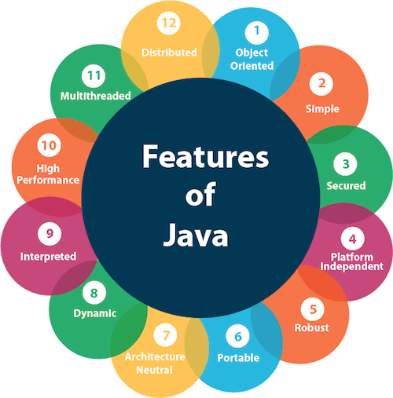

1. [Simple](https://www.javatpoint.com/features-of-java#Simple)
2. [Object-Oriented](https://www.javatpoint.com/features-of-java#Object-Oriented)
3. [Portable](https://www.javatpoint.com/features-of-java#Portable)
4. [Platform independent](https://www.javatpoint.com/features-of-java#Platform-independent)
5. [Secured](https://www.javatpoint.com/features-of-java#Secured)
6. [Robust](https://www.javatpoint.com/features-of-java#Robust)
7. [Architecture neutral](https://www.javatpoint.com/features-of-java#Architecture-neutral)
8. [Interpreted](https://www.javatpoint.com/features-of-java#Interpreted)
9. [High Performance](https://www.javatpoint.com/features-of-java#High-Performance)
10. [Multithreaded](https://www.javatpoint.com/features-of-java#Multithreaded)
11. [Distributed](https://www.javatpoint.com/features-of-java#Distributed)
12. [Dynamic](https://www.javatpoint.com/features-of-java#Dynamic)

Simple

Java is very easy to learn, and its syntax is simple, clean and easy to understand. According to Sun Microsystem, Java language is a simple programming language because:

* Java syntax is based on C++ (so easier for programmers to learn it after C++).
* Java has removed many complicated and rarely-used features, for example, explicit pointers, operator overloading, etc.
* There is no need to remove unreferenced objects because there is an Automatic Garbage Collection in Java.

Object-oriented

Java is an [object-oriented](https://www.javatpoint.com/java-oops-concepts) programming language. Everything in Java is an object. Object-oriented means we organize our software as a combination of different types of objects that incorporate both data and behavior.

Object-oriented programming (OOPs) is a methodology that simplifies software development and maintenance by providing some rules.

Basic concepts of OOPs are:

1. [Object](https://www.javatpoint.com/object-and-class-in-java)
2. [Class](https://www.javatpoint.com/object-and-class-in-java#class)
3. [Inheritance](https://www.javatpoint.com/inheritance-in-java)
4. [Polymorphism](https://www.javatpoint.com/runtime-polymorphism-in-java)
5. [Abstraction](https://www.javatpoint.com/abstract-class-in-java)
6. [Encapsulation](https://www.javatpoint.com/encapsulation)

Platform Independent

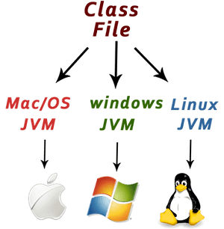

Java is platform independent because it is different from other languages like [C](https://www.javatpoint.com/c-programming-language-tutorial), [C++](https://www.javatpoint.com/cpp-tutorial), etc. which are compiled into platform specific machines while Java is a write once, run anywhere language. A platform is the hardware or software environment in which a program runs.

There are two types of platforms software-based and hardware-based. Java provides a software-based platform.

The Java platform differs from most other platforms in the sense that it is a software-based platform that runs on top of other hardware-based platforms. It has two components:

1. Runtime Environment
2. API(Application Programming Interface)

Java code can be executed on multiple platforms, for example, Windows, Linux, Sun Solaris, Mac/OS, etc. Java code is compiled by the compiler and converted into bytecode. This bytecode is a platform-independent code because it can be run on multiple platforms, i.e., Write Once and Run Anywhere (WORA).

Secured

Java is best known for its security. With Java, we can develop virus-free systems. Java is secured because:

* **No explicit pointer**
* **Java Programs run inside a virtual machine sandbox**

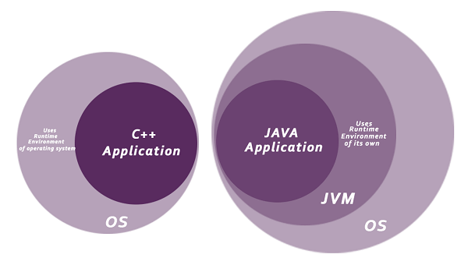

* **Classloader:** Classloader in Java is a part of the Java Runtime Environment (JRE) which is used to load Java classes into the Java Virtual Machine dynamically. It adds security by separating the package for the classes of the local file system from those that are imported from network sources.
* **Bytecode Verifier:** It checks the code fragments for illegal code that can violate access rights to objects.
* **Security Manager:** It determines what resources a class can access such as reading and writing to the local disk.

Java language provides these securities by default. Some security can also be provided by an application developer explicitly through SSL, JAAS, Cryptography, etc.

Robust

The English mining of Robust is strong. Java is robust because:

* It uses strong memory management.
* There is a lack of pointers that avoids security problems.
* Java provides automatic garbage collection which runs on the Java Virtual Machine to get rid of objects which are not being used by a Java application anymore.
* There are exception handling and the type checking mechanism in Java. All these points make Java robust.

Architecture-neutral

Java is architecture neutral because there are no implementation dependent features, for example, the size of primitive types is fixed.

In C programming, int data type occupies 2 bytes of memory for 32-bit architecture and 4 bytes of memory for 64-bit architecture. However, it occupies 4 bytes of memory for both 32 and 64-bit architectures in Java.

Portable

Java is portable because it facilitates you to carry the Java bytecode to any platform. It doesn't require any implementation.

High-performance

Java is faster than other traditional interpreted programming languages because Java bytecode is "close" to native code. It is still a little bit slower than a compiled language (e.g., C++). Java is an interpreted language that is why it is slower than compiled languages, e.g., C, C++, etc.

Distributed

Java is distributed because it facilitates users to create distributed applications in Java. RMI and EJB are used for creating distributed applications. This feature of Java makes us able to access files by calling the methods from any machine on the internet.

Multi-threaded

A thread is like a separate program, executing concurrently. We can write Java programs that deal with many tasks at once by defining multiple threads. The main advantage of multi-threading is that it doesn't occupy memory for each thread. It shares a common memory area. Threads are important for multi-media, Web applications, etc.

Dynamic

Java is a dynamic language. It supports the dynamic loading of classes. It means classes are loaded on demand. It also supports functions from its native languages, i.e., C and C++.

Difference between JDK, JRE, and JVM

1. [A summary of JVM](https://www.javatpoint.com/difference-between-jdk-jre-and-jvm)
2. [Java Runtime Environment (JRE)](https://www.javatpoint.com/difference-between-jdk-jre-and-jvm#jre)
3. [Java Development Kit (JDK)](https://www.javatpoint.com/difference-between-jdk-jre-and-jvm#jdk)

We must understand the differences between JDK, JRE, and JVM before proceeding further to [Java](https://www.javatpoint.com/java-tutorial). See the brief overview of JVM here.

If you want to get the detailed knowledge of Java Virtual Machine, move to the next page. Firstly, let's see the differences between the JDK, JRE, and JVM.

JVM

JVM (Java Virtual Machine) is an abstract machine. It is called a virtual machine because it doesn't physically exist. It is a specification that provides a runtime environment in which Java bytecode can be executed. It can also run those programs which are written in other languages and compiled to Java bytecode.

The JVM performs the following main tasks:

* Loads code
* Verifies code
* Executes code
* Provides runtime environment

[More Details.](https://www.javatpoint.com/internal-details-of-jvm)

JRE

JRE is an acronym for Java Runtime Environment. It is also written as Java RTE. The Java Runtime Environment is a set of software tools which are used for developing Java applications. It is used to provide the runtime environment. It is the implementation of JVM. It physically exists. It contains a set of libraries + other files that JVM uses at runtime.

The implementation of JVM is also actively released by other companies besides Sun Micro Systems.

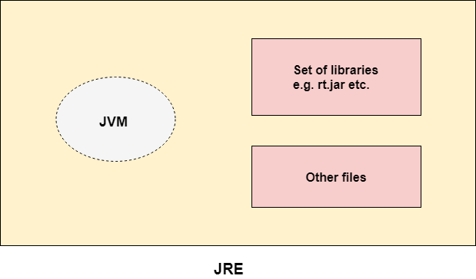

JDK

JDK is an acronym for Java Development Kit. The Java Development Kit (JDK) is a software development environment which is used to develop Java applications and [applets](https://www.javatpoint.com/java-applet). It physically exists. It contains JRE + development tools.

JDK is an implementation of any one of the below given Java Platforms released by Oracle Corporation:

* Standard Edition Java Platform
* Enterprise Edition Java Platform
* Micro Edition Java Platform

The JDK contains a private Java Virtual Machine (JVM) and a few other resources such as an interpreter/loader (java), a compiler (javac), an archiver (jar), a documentation generator (Javadoc), etc. to complete the development of a Java Application.

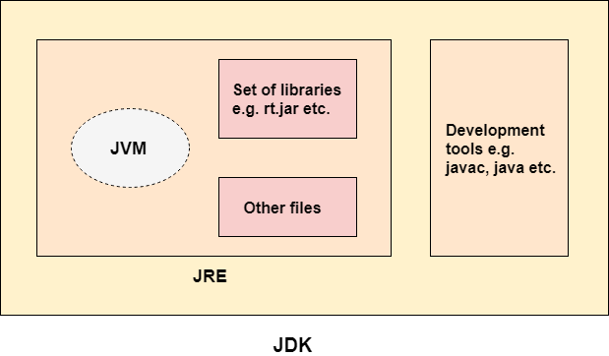

**class** Simple{

**public** **static** **void** main(String args[]){

     System.out.println("Hello Java");

    }

}

Steps:

1) javac Simple.java ->.class ---🡪byte code instructions

2) java Simple

U need to convert byte code into machine language instructions so that it will understand by every one

What it does

The JVM performs following operation:

* Loads code
* Verifies code
* Executes code
* Provides runtime environment

.

## JVM Architecture

Let's understand the internal architecture of JVM. It contains classloader, memory area, execution engine etc.

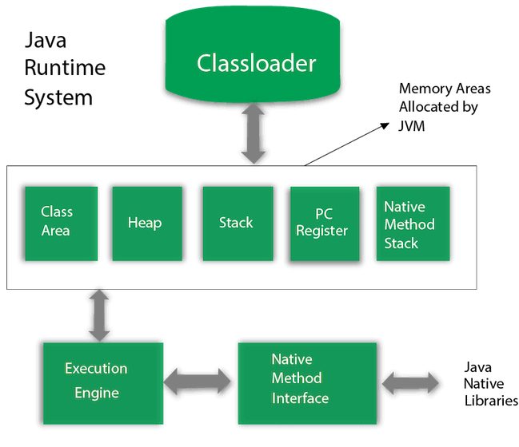

Class(Method) Area

Class(Method) Area stores per-class structures such as the runtime constant pool, field and method data, the code for methods.

3) Heap

It is the runtime data area in which objects are allocated.

4) Stack

Java Stack stores frames. It holds local variables and partial results, and plays a part in method invocation and return.

Each thread has a private JVM stack, created at the same time as thread.

A new frame is created each time a method is invoked. A frame is destroyed when its method invocation completes.

5) Program Counter Register

PC (program counter) register contains the address of the Java virtual machine instruction currently being executed.

6) Native Method Stack

It contains all the native methods used in the application.

7) Execution Engine

It contains:

1. **A virtual processor**
2. **Interpreter:** Read bytecode stream then execute the instructions.
3. **Just-In-Time(JIT) compiler:** It is used to improve the performance. JIT compiles parts of the byte code that have similar functionality at the same time, and hence reduces the amount of time needed for compilation. Here, the term "compiler" refers to a translator from the instruction set of a Java virtual machine (JVM) to the instruction set of a specific CPU.

8) Java Native Interface

Java Native Interface (JNI) is a framework which provides an interface to communicate with another application written in another language like C, C++, Assembly etc. Java uses JNI framework to send output to the Console or interact with OS libraries.

# Java Variables

A variable is a container which holds the value while the [Java program](https://www.javatpoint.com/simple-program-of-java) is executed. A variable is assigned with a data type.

Variable is a name of memory location. There are three types of variables in java: local, instance and static.

There are two types of [data types in Java](https://www.javatpoint.com/java-data-types): primitive and non-primitive.

## Variable

A variable is the name of a reserved area allocated in memory. In other words, it is a name of the memory location. It is a combination of "vary + able" which means its value can be changed.

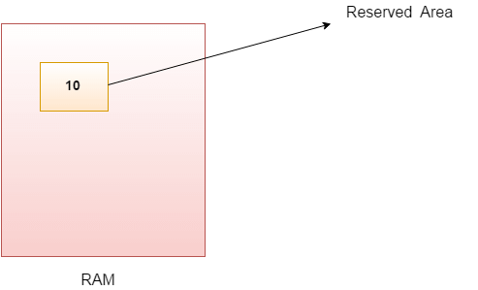

1. **int** data=50;//Here data is variable

### Types of Variables

There are three types of variables in [Java](https://www.javatpoint.com/java-tutorial):

* local variable
* instance variable
* static variable

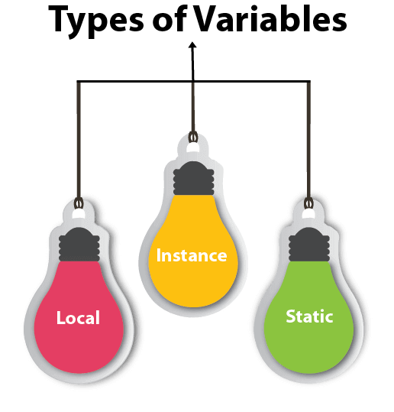

#### 1) Local Variable

A variable declared inside the body of the method is called local variable. You can use this variable only within that method and the other methods in the class aren't even aware that the variable exists.

A local variable cannot be defined with "static" keyword.

#### 2) Instance Variable

A variable declared inside the class but outside the body of the method, is called an instance variable. It is not declared as [static](https://www.javatpoint.com/static-keyword-in-java).

It is called an instance variable because its value is instance-specific and is not shared among instances.

#### 3) Static variable

A variable that is declared as static is called a static variable. It cannot be local. You can create a single copy of the static variable and share it among all the instances of the class. Memory allocation for static variables happens only once when the class is loaded in the memory.

**package** com.demo5;

**public** **class** Sample {

**int** id=10;//instance

**static** String *s*="sample"; //static

**public** **static** **void** main(String[] args) {

Sample sam=**new** Sample();

System.***out***.println(sam.id);

System.***out***.println(Sample.*s*);

}

}

### Example to understand the types of variables in java

1. **public** **class** A
2. {
3. **static** **int** m=100;//static variable
4. **void** method()
5. {
6. **int** n=90;//local variable
7. }
8. **public** **static** **void** main(String args[])
9. {
10. **int** data=50;//instance variable
11. }
12. }//end of class

### Java Variable Example: Add Two Numbers

1. **public** **class** Simple{
2. **public** **static** **void** main(String[] args){
3. **int** a=10;
4. **int** b=10;
5. **int** c=a+b;
6. System.out.println(c);
7. }
8. }

**Output:**

20

### Java Variable Example: Widening

1. **public** **class** Simple{
2. **public** **static** **void** main(String[] args){
3. **int** a=10;
4. **float** f=a;
5. System.out.println(a);
6. System.out.println(f);
7. }}

**Output:**

10

10.0

### Java Variable Example: Narrowing (Typecasting)

1. **public** **class** Simple{
2. **public** **static** **void** main(String[] args){
3. **float** f=10.5f;
4. //int a=f;//Compile time error
5. **int** a=(**int**)f;
6. System.out.println(f);
7. System.out.println(a);
8. }}

**Output:**

10.5

10

### Java Variable Example: Overflow

1. **class** Simple{
2. **public** **static** **void** main(String[] args){
3. //Overflow
4. **int** a=130;
5. **byte** b=(**byte**)a;
6. System.out.println(a);
7. System.out.println(b);
8. }}

**Output:**

130

-126

### Java Variable Example: Adding Lower Type

1. **class** Simple{
2. **public** **static** **void** main(String[] args){
3. **byte** a=10;
4. **byte** b=10;
5. //byte c=a+b;//Compile Time Error: because a+b=20 will be int
6. **byte** c=(**byte**)(a+b);
7. System.out.println(c);
8. }}

# Data Types in Java

Data types specify the different sizes and values that can be stored in the variable. There are two types of data types in Java:

1. **Primitive data types:** The primitive data types include boolean, char, byte, short, int, long, float and double.
2. **Non-primitive data types:** The non-primitive data types include [Classes](https://www.javatpoint.com/object-and-class-in-java), [Interfaces](https://www.javatpoint.com/interface-in-java), and [Arrays](https://www.javatpoint.com/array-in-java).

## Java Primitive Data Types

In Java language, primitive data types are the building blocks of data manipulation. These are the most basic data types available in [Java language](https://www.javatpoint.com/java-tutorial).

Java is a statically-typed programming language. It means, all [variables](https://www.javatpoint.com/java-variables) must be declared before its use. That is why we need to declare variable's type and name.

There are 8 types of primitive data types:

Exception Handling in Java - Javatpoint

* boolean data type
* byte data type
* char data type
* short data type
* int data type
* long data type
* float data type
* double data type

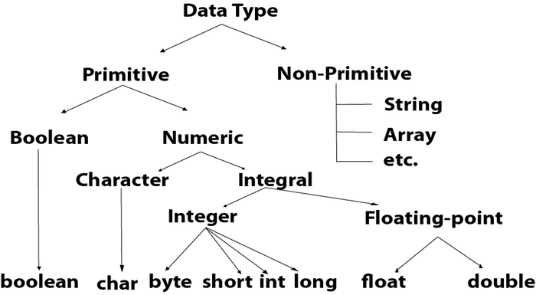

|  |  |  |
| --- | --- | --- |
| **Data Type** | **Default Value** | **Default size** |
| boolean | false | 1 bit |
| char | '\u0000' | 2 byte |
| byte | 0 | 1 byte |
| short | 0 | 2 byte |
| int | 0 | 4 byte |
| long | 0L | 8 byte |
| float | 0.0f | 4 byte |
| double | 0.0d | 8 byte |

## Boolean Data Type

The Boolean data type is used to store only two possible values: true and false. This data type is used for simple flags that track true/false conditions.

The Boolean data type specifies one bit of information, but its "size" can't be defined precisely.

**Example:**

1. Boolean one = **false**

## Byte Data Type

The byte data type is an example of primitive data type. It isan 8-bit signed two's complement integer. Its value-range lies between -128 to 127 (inclusive). Its minimum value is -128 and maximum value is 127. Its default value is 0.

The byte data type is used to save memory in large arrays where the memory savings is most required. It saves space because a byte is 4 times smaller than an integer. It can also be used in place of "int" data type.

**Example:**

1. **byte** a = 10, **byte** b = -20

## Short Data Type

The short data type is a 16-bit signed two's complement integer. Its value-range lies between -32,768 to 32,767 (inclusive). Its minimum value is -32,768 and maximum value is 32,767. Its default value is 0.

The short data type can also be used to save memory just like byte data type. A short data type is 2 times smaller than an integer.

**Example:**

1. **short** s = 10000, **short** r = -5000

## Int Data Type

The int data type is a 32-bit signed two's complement integer. Its value-range lies between - 2,147,483,648 (-2^31) to 2,147,483,647 (2^31 -1) (inclusive). Its minimum value is - 2,147,483,648and maximum value is 2,147,483,647. Its default value is 0.

The int data type is generally used as a default data type for integral values unless if there is no problem about memory.

**Example:**

1. **int** a = 100000, **int** b = -200000

## Long Data Type

The long data type is a 64-bit two's complement integer. Its value-range lies between -9,223,372,036,854,775,808(-2^63) to 9,223,372,036,854,775,807(2^63 -1)(inclusive). Its minimum value is - 9,223,372,036,854,775,808and maximum value is 9,223,372,036,854,775,807. Its default value is 0. The long data type is used when you need a range of values more than those provided by int.

**Example:**

1. **long** a = 100000L, **long** b = -200000L

## Float Data Type

The float data type is a single-precision 32-bit IEEE 754 floating point.Its value range is unlimited. It is recommended to use a float (instead of double) if you need to save memory in large arrays of floating point numbers. The float data type should never be used for precise values, such as currency. Its default value is 0.0F.

**Example:**

1. **float** f1 = 234.5f

## Double Data Type

The double data type is a double-precision 64-bit IEEE 754 floating point. Its value range is unlimited. The double data type is generally used for decimal values just like float. The double data type also should never be used for precise values, such as currency. Its default value is 0.0d.

**Example:**

1. **double** d1 = 12.3

## Char Data Type

The char data type is a single 16-bit Unicode character. Its value-range lies between '\u0000' (or 0) to '\uffff' (or 65,535 inclusive).The char data type is used to store characters.

**Example:**

1. **char** letterA = 'A'

# Operators in Java:

## Java Operator Precedence

|  |  |  |
| --- | --- | --- |
| **Operator Type** | **Category** | **Precedence** |
| Unary | postfix | expr++ expr-- |
| prefix | ++expr --expr +expr -expr ~ ! |
| Arithmetic | multiplicative | * / % |
| additive | + - |
| Shift | shift | << >> >>> |
| Relational | comparison | < > <= >= instanceof |
| equality | == != |
| Bitwise | bitwise AND | & |
| bitwise exclusive OR | ^ |
| bitwise inclusive OR | | |
| Logical | logical AND | && |
| logical OR | || |
| Ternary | ternary | ? : |
| Assignment | assignment | = += -= *= /= %= &= ^= |= <<= >>= >>>= |

### Java Unary Operator Example: ++ and --

1. **public** **class** OperatorExample{
2. **public** **static** **void** main(String args[]){
3. **int** x=10;
4. System.out.println(x++);//10 (11)
5. System.out.println(++x);//12
6. System.out.println(x--);//12 (11)
7. System.out.println(--x);//10
8. }}

### Java Arithmetic Operator Example

1. **public** **class** OperatorExample{
2. **public** **static** **void** main(String args[]){
3. **int** a=10;
4. **int** b=5;
5. System.out.println(a+b);//15
6. System.out.println(a-b);//5
7. System.out.println(a*b);//50
8. System.out.println(a/b);//2
9. System.out.println(a%b);//0
10. }}

### Java Ternary Operator Example

1. **public** **class** OperatorExample{
2. **public** **static** **void** main(String args[]){
3. **int** a=2;
4. **int** b=5;
5. **int** min=(a<b)?a:b;
6. System.out.println(min);
7. }}

### Java Assignment Operator

Java assignment operator is one of the most common operators. It is used to assign the value on its right to the operand on its left.

### Java Assignment Operator Example

1. **public** **class** OperatorExample{
2. **public** **static** **void** main(String args[]){
3. **int** a=10;
4. **int** b=20;
5. a+=4;//a=a+4 (a=10+4)
6. b-=4;//b=b-4 (b=20-4)
7. System.out.println(a);
8. System.out.println(b);
9. }}

# Java Keywords

Java keywords are also known as reserved words. Keywords are particular words that act as a key to a code. These are predefined words by Java so they cannot be used as a variable or object name or class name.

## List of Java Keywords

A list of Java keywords or reserved words are given below:

1. [**abstract**](https://www.javatpoint.com/abstract-keyword-in-java)**:** Java abstract keyword is used to declare an abstract class. An abstract class can provide the implementation of the interface. It can have abstract and non-abstract methods.
2. [**boolean:**](https://www.javatpoint.com/boolean-keyword-in-java) Java boolean keyword is used to declare a variable as a boolean type. It can hold True and False values only.
3. [**break**](https://www.javatpoint.com/java-break)**:** Java break keyword is used to break the loop or switch statement. It breaks the current flow of the program at specified conditions.
4. [**byte**](https://www.javatpoint.com/byte-keyword-in-java)**:** Java byte keyword is used to declare a variable that can hold 8-bit data values.
5. [**case**](https://www.javatpoint.com/case-keyword-in-java)**:** Java case keyword is used with the switch statements to mark blocks of text.
6. [**catch**](https://www.javatpoint.com/try-catch-block)**:** Java catch keyword is used to catch the exceptions generated by try statements. It must be used after the try block only.
7. [**char**](https://www.javatpoint.com/char-keyword-in-java)**:** Java char keyword is used to declare a variable that can hold unsigned 16-bit Unicode characters
8. [**class**](https://www.javatpoint.com/class-keyword-in-java)**:** Java class keyword is used to declare a class.
9. [**continue**](https://www.javatpoint.com/java-continue)**:** Java continue keyword is used to continue the loop. It continues the current flow of the program and skips the remaining code at the specified condition.
10. [**default**](https://www.javatpoint.com/default-keyword-in-java)**:** Java default keyword is used to specify the default block of code in a switch statement.
11. [**do**](https://www.javatpoint.com/java-do-while-loop)**:** Java do keyword is used in the control statement to declare a loop. It can iterate a part of the program several times.
12. [**double**](https://www.javatpoint.com/double-keyword-in-java)**:** Java double keyword is used to declare a variable that can hold 64-bit floating-point number.
13. [**else**](https://www.javatpoint.com/java-if-else)**:** Java else keyword is used to indicate the alternative branches in an if statement.
14. [**enum**](https://www.javatpoint.com/enum-in-java)**:** Java enum keyword is used to define a fixed set of constants. Enum constructors are always private or default.
15. [**extends**](https://www.javatpoint.com/inheritance-in-java)**:** Java extends keyword is used to indicate that a class is derived from another class or interface.
16. [**final**](https://www.javatpoint.com/final-keyword)**:** Java final keyword is used to indicate that a variable holds a constant value. It is used with a variable. It is used to restrict the user from updating the value of the variable.
17. [**finally**](https://www.javatpoint.com/finally-block-in-exception-handling)**:** Java finally keyword indicates a block of code in a try-catch structure. This block is always executed whether an exception is handled or not.
18. [**float**](https://www.javatpoint.com/float-keyword-in-java)**:** Java float keyword is used to declare a variable that can hold a 32-bit floating-point number.
19. [**for**](https://www.javatpoint.com/java-for-loop)**:** Java for keyword is used to start a for loop. It is used to execute a set of instructions/functions repeatedly when some condition becomes true. If the number of iteration is fixed, it is recommended to use for loop.
20. [**if**](https://www.javatpoint.com/java-if-else)**:** Java if keyword tests the condition. It executes the if block if the condition is true.
21. [**implements**](https://www.javatpoint.com/interface-in-java)**:** Java implements keyword is used to implement an interface.
22. [**import**](https://www.javatpoint.com/package)**:** Java import keyword makes classes and interfaces available and accessible to the current source code.
23. [**instanceof**](https://www.javatpoint.com/downcasting-with-instanceof-operator)**:** Java instanceof keyword is used to test whether the object is an instance of the specified class or implements an interface.
24. [**int**](https://www.javatpoint.com/int-keyword-in-java)**:** Java int keyword is used to declare a variable that can hold a 32-bit signed integer.
25. [**interface**](https://www.javatpoint.com/interface-in-java)**:** Java interface keyword is used to declare an interface. It can have only abstract methods.
26. [**long**](https://www.javatpoint.com/long-keyword-in-java)**:** Java long keyword is used to declare a variable that can hold a 64-bit integer.
27. **native:** Java native keyword is used to specify that a method is implemented in native code using JNI (Java Native Interface).
28. [**new**](https://www.javatpoint.com/new-keyword-in-java)**:** Java new keyword is used to create new objects.
29. [**null**](https://www.javatpoint.com/null-keyword-in-java)**:** Java null keyword is used to indicate that a reference does not refer to anything. It removes the garbage value.
30. [**package**](https://www.javatpoint.com/package)**:** Java package keyword is used to declare a Java package that includes the classes.
31. [**private**](https://www.javatpoint.com/private-keyword-in-java)**:** Java private keyword is an access modifier. It is used to indicate that a method or variable may be accessed only in the class in which it is declared.
32. [**protected**](https://www.javatpoint.com/protected-keyword-in-java)**:** Java protected keyword is an access modifier. It can be accessible within the package and outside the package but through inheritance only. It can't be applied with the class.
33. [**public**](https://www.javatpoint.com/public-keyword-in-java)**:** Java public keyword is an access modifier. It is used to indicate that an item is accessible anywhere. It has the widest scope among all other modifiers.
34. [**return**](https://www.javatpoint.com/return-keyword-in-java)**:** Java return keyword is used to return from a method when its execution is complete.
35. [**short**](https://www.javatpoint.com/short-keyword-in-java)**:** Java short keyword is used to declare a variable that can hold a 16-bit integer.
36. [**static**](https://www.javatpoint.com/static-keyword-in-java)**:** Java static keyword is used to indicate that a variable or method is a class method. The static keyword in Java is mainly used for memory management.
37. [**strictfp**](https://www.javatpoint.com/strictfp-keyword)**:** Java strictfp is used to restrict the floating-point calculations to ensure portability.
38. [**super**](https://www.javatpoint.com/super-keyword)**:** Java super keyword is a reference variable that is used to refer to parent class objects. It can be used to invoke the immediate parent class method.
39. [**switch**](https://www.javatpoint.com/java-switch)**:** The Java switch keyword contains a switch statement that executes code based on test value. The switch statement tests the equality of a variable against multiple values.
40. [**synchronized**](https://www.javatpoint.com/synchronization-in-java)**:** Java synchronized keyword is used to specify the critical sections or methods in multithreaded code.
41. [**this**](https://www.javatpoint.com/this-keyword)**:** Java this keyword can be used to refer the current object in a method or constructor.
42. [**throw**](https://www.javatpoint.com/throw-keyword)**:** The Java throw keyword is used to explicitly throw an exception. The throw keyword is mainly used to throw custom exceptions. It is followed by an instance.
43. [**throws**](https://www.javatpoint.com/throws-keyword-and-difference-between-throw-and-throws)**:** The Java throws keyword is used to declare an exception. Checked exceptions can be propagated with throws.
44. [**transient**](https://www.javatpoint.com/transient-keyword)**:** Java transient keyword is used in serialization. If you define any data member as transient, it will not be serialized.
45. [**try**](https://www.javatpoint.com/try-catch-block)**:** Java try keyword is used to start a block of code that will be tested for exceptions. The try block must be followed by either catch or finally block.
46. **void:** Java void keyword is used to specify that a method does not have a return value.
47. [**volatile**](https://www.javatpoint.com/volatile-keyword-in-java)**:** Java volatile keyword is used to indicate that a variable may change asynchronously.
48. [**while**](https://www.javatpoint.com/java-while-loop)**:** Java while keyword is used to start a while loop. This loop iterates a part of the program several times. If the number of iteration is not fixed, it is recommended to use the while loop.

**Control Statements:**

Java provides three types of control flow statements.

1. Decision Making statements
   * if statements
   * switch statement
2. Loop statements
   * do while loop
   * while loop
   * for loop
   * for-each loop
3. Jump statements
   * break statement
   * continue statement

**Example:**

1. **public** **class** Student {
2. **public** **static** **void** main(String[] args) {
3. String city = "Delhi";
4. **if**(city == "Meerut") {
5. System.out.println("city is meerut");
6. }**else** **if** (city == "Noida") {
7. System.out.println("city is noida");
8. }**else** **if**(city == "Agra") {
9. System.out.println("city is agra");
10. }**else** {
11. System.out.println(city);
12. }
13. }
14. }

**Switch:**

**Student.java**

1. **public** **class** Student **implements** Cloneable {
2. **public** **static** **void** main(String[] args) {
3. **int** num = 2;
4. **switch** (num){
5. **case** 0:
6. System.out.println("number is 0");
7. **break**;
8. **case** 1:
9. System.out.println("number is 1");
10. **break**;
11. **default**:
12. System.out.println(num);
13. }
14. }
15. }

**For:**

1. **public** **class** Calculattion {
2. **public** **static** **void** main(String[] args) {
3. // TODO Auto-generated method stub
4. **int** sum = 0;
5. **for**(**int** j = 1; j<=10; j++) {
6. sum = sum + j;
7. }
8. System.out.println("The sum of first 10 natural numbers is " + sum);
9. }
10. }

**For each:**

**Calculation.java**

1. **public** **class** Calculation {
2. **public** **static** **void** main(String[] args) {
3. // TODO Auto-generated method stub
4. String[] names = {"Java","C","C++","Python","JavaScript"};
5. System.out.println("Printing the content of the array names:\n");
6. **for**(String name:names) {
7. System.out.println(name);
8. }
9. }
10. }

**While:**

**Calculation .java**

1. **public** **class** Calculation {
2. **public** **static** **void** main(String[] args) {
3. // TODO Auto-generated method stub
4. **int** i = 0;
5. System.out.println("Printing the list of first 10 even numbers \n");
6. **while**(i<=10) {
7. System.out.println(i);
8. i = i + 2;
9. }
10. }
11. }

**Do while:**

1. **public** **class** Calculation {
2. **public** **static** **void** main(String[] args) {
3. // TODO Auto-generated method stub
4. **int** i = 0;
5. System.out.println("Printing the list of first 10 even numbers \n");
6. **do** {
7. System.out.println(i);
8. i = i + 2;
9. }**while**(i<=10);
10. }
11. }

**Break:**

**BreakExample.java**

1. **public** **class** BreakExample {
3. **public** **static** **void** main(String[] args) {
4. // TODO Auto-generated method stub
5. **for**(**int** i = 0; i<= 10; i++) {
6. System.out.println(i);
7. **if**(i==6) {
8. **break**;
9. }
10. }
11. }
12. }

### Java continue statement

Unlike break statement, the [continue statement](https://www.javatpoint.com/java-continue) doesn't break the loop, whereas, it skips the specific part of the loop and jumps to the next iteration of the loop immediately.

Consider the following example to understand the functioning of the continue statement in Java.

1. **public** **class** ContinueExample {
3. **public** **static** **void** main(String[] args) {
4. // TODO Auto-generated method stub
6. **for**(**int** i = 0; i<= 2; i++) {
8. **for** (**int** j = i; j<=5; j++) {
10. **if**(j == 4) {
11. **continue**;
12. }
13. System.out.println(j);
14. }
15. }
16. }
18. }

# Method in Java

In general, a **method** is a way to perform some task. Similarly, the **method in Java** is a collection of instructions that performs a specific task. It provides the reusability of code. We can also easily modify code using **methods**. In this section, we will learn **what is a method in Java, types of methods, method declaration,** and **how to call a method in Java**.

## What is a method in Java?

A **method** is a block of code or collection of statements or a set of code grouped together to perform a certain task or operation. It is used to achieve the **reusability** of code. We write a method once and use it many times. We do not require to write code again and again. It also provides the **easy modification** and **readability** of code, just by adding or removing a chunk of code. The method is executed only when we call or invoke it.

The most important method in Java is the **main()** method. If you want to read more about the main() method, go through the

### Method Declaration

The method declaration provides information about method attributes, such as visibility, return-type, name, and arguments. It has six components that are known as **method header**, as we have shown in the following figure.

21.2M

464

How to find Nth Highest Salary in SQL

**Next**

**Stay**

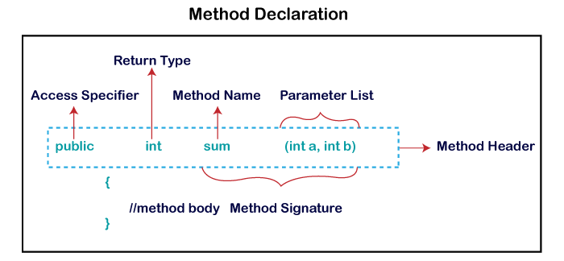

**Method Signature:** Every method has a method signature. It is a part of the method declaration. It includes the **method name** and **parameter list**.

**Access Specifier:** Access specifier or modifier is the access type of the method. It specifies the visibility of the method. Java provides **four** types of access specifier:

* **Public:** The method is accessible by all classes when we use public specifier in our application.
* **Private:** When we use a private access specifier, the method is accessible only in the classes in which it is defined.
* **Protected:** When we use protected access specifier, the method is accessible within the same package or subclasses in a different package.
* **Default:** When we do not use any access specifier in the method declaration, Java uses default access specifier by default. It is visible only from the same package only.

**Return Type:** Return type is a data type that the method returns. It may have a primitive data type, object, collection, void, etc. If the method does not return anything, we use void keyword.

**Method Name:** It is a unique name that is used to define the name of a method. It must be corresponding to the functionality of the method. Suppose, if we are creating a method for subtraction of two numbers, the method name must be **subtraction().** A method is invoked by its name.

**Parameter List:** It is the list of parameters separated by a comma and enclosed in the pair of parentheses. It contains the data type and variable name. If the method has no parameter, left the parentheses blank.

**Method Body:** It is a part of the method declaration. It contains all the actions to be performed. It is enclosed within the pair of curly braces.

## Naming a Method

While defining a method, remember that the method name must be a **verb** and start with a **lowercase** letter. If the method name has more than two words, the first name must be a verb followed by adjective or noun. In the multi-word method name, the first letter of each word must be in **uppercase** except the first word. For example:

**Single-word method name:** sum(), area()

**Multi-word method name:** areaOfCircle(), stringComparision()

It is also possible that a method has the same name as another method name in the same class, it is known as **method overloading**.

## Types of Method

There are two types of methods in Java:

* Predefined Method
* User-defined Method

### Predefined Method

In Java, predefined methods are the method that is already defined in the Java class libraries is known as predefined methods. It is also known as the **standard library method** or **built-in method**. We can directly use these methods just by calling them in the program at any point. Some pre-defined methods are **length(), equals(), compareTo(), sqrt(),** etc. When we call any of the predefined methods in our program, a series of codes related to the corresponding method runs in the background that is already stored in the library.

Each and every predefined method is defined inside a class. Such as **print()** method is defined in the **java.io.PrintStream** class. It prints the statement that we write inside the method. For example, **print("Java")**, it prints Java on the console.

Let's see an example of the predefined method.

**Demo.java**

1. **public** **class** Demo
2. {
3. **public** **static** **void** main(String[] args)
4. {
5. // using the max() method of Math class
6. System.out.print("The maximum number is: " + Math.max(9,7));
7. }
8. }

**Output:**

The maximum number is: 9

In the above example, we have used three predefined methods **main(), print(),** and **max()**. We have used these methods directly without declaration because they are predefined. The print() method is a method of **PrintStream** class that prints the result on the console. The max() method is a method of the **Math** class that returns the greater of two numbers.

We can also see the method signature of any predefined method by using the link <https://docs.oracle.com/>. When we go through the link and see the max() method signature, we find the following:

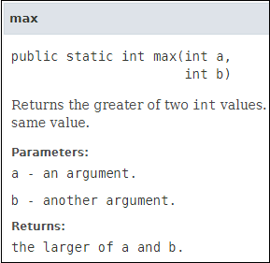

In the above method signature, we see that the method signature has access specifier **public**, non-access modifier **static**, return type **int**, method name **max(),** parameter list **(int a, int b).** In the above example, instead of defining the method, we have just invoked the method. This is the advantage of a predefined method. It makes programming less complicated.

Similarly, we can also see the method signature of the print() method.

### User-defined Method

The method written by the user or programmer is known as **a user-defined** method. These methods are modified according to the requirement.

### How to Create a User-defined Method

Let's create a user defined method that checks the number is even or odd. First, we will define the method.

1. //user defined method
2. **public** **static** **void** findEvenOdd(**int** num)
3. {
4. //method body
5. **if**(num%2==0)
6. System.out.println(num+" is even");
7. **else**
8. System.out.println(num+" is odd");
9. }

We have defined the above method named findevenodd(). It has a parameter **num** of type int. The method does not return any value that's why we have used void. The method body contains the steps to check the number is even or odd. If the number is even, it prints the number **is even**, else prints the number **is odd**.

### How to Call or Invoke a User-defined Method

Once we have defined a method, it should be called. The calling of a method in a program is simple. When we call or invoke a user-defined method, the program control transfer to the called method.

1. **import** java.util.Scanner;
2. **public** **class** EvenOdd
3. {
4. **public** **static** **void** main (String args[])
5. {

Int num=10;

1. //method calling
2. findEvenOdd(num);
3. }

In the above code snippet, as soon as the compiler reaches at line **findEvenOdd(num),** the control transfer to the method and gives the output accordingly.

# Constructors in Java:

In [Java](https://www.javatpoint.com/java-tutorial)

, a constructor is a block of codes similar to the method. It is called when an instance of the [class](https://www.javatpoint.com/object-and-class-in-java)

is created. At the time of calling constructor, memory for the object is allocated in the memory.

It is a special type of method which is used to initialize the object.

Every time an object is created using the new() keyword, at least one constructor is called.

It calls a default constructor if there is no constructor available in the class. In such case, Java compiler provides a default constructor by default.

### Rules for creating Java constructor

There are two rules defined for the constructor.

1. Constructor name must be the same as its class name
2. A Constructor must have no explicit return type
3. A Java constructor cannot be abstract, static, final, and synchronized

#### Note: We can use [access modifiers](https://www.javatpoint.com/access-modifiers)

#### while declaring a constructor. It controls the object creation. In other words, we can have private, protected, public or default constructor in Java.

## Types of Java constructors

There are two types of constructors in Java:

1. Default constructor (no-arg constructor)
2. Parameterized constructor
3. **class** Bike1{
4. //creating a default constructor
5. Bike1(){System.out.println("Bike is created");}
6. //main method
7. **public** **static** **void** main(String args[]){
8. //calling a default constructor
9. Bike1 b=**new** Bike1();
10. }
11. }

**public** **class** Student3 {

**int** id;

String name;

//creating a parameterized constructor

Student3(**int** i,String n){

id = i;

name = n;

}

//method to display the values

**void** display(){System.***out***.println(id+" "+name);}

**public** **static** **void** main(String args[]){

//creating objects and passing values

Student3 s1 = **new** Student3(111,"Karan");

Student3 s2 = **new** Student3(222,"Aryan");

//calling method to display the values of object

s1.display();

s2.display();

}

}

# Parameterized constructor:

1. **class** Student4{
2. **int** id;
3. String name;
4. //creating a parameterized constructor
5. Student4(**int** i,String n){
6. id = i;
7. name = n;
8. }
9. //method to display the values
10. **void** display(){System.out.println(id+" "+name);}
12. **public** **static** **void** main(String args[]){
13. //creating objects and passing values
14. Student4 s1 = **new** Student4(111,"Karan");
15. Student4 s2 = **new** Student4(222,"Aryan");
16. //calling method to display the values of object
17. s1.display();
18. s2.display();
19. }
20. }

|  |  |
| --- | --- |
| **Java Constructor** | **Java Method** |
| A constructor is used to initialize the state of an object. | A method is used to expose the behavior of an object. |
| A constructor must not have a return type. | A method must have a return type. |
| The constructor is invoked implicitly. | The method is invoked explicitly. |
| The Java compiler provides a default constructor if you don't have any constructor in a class. | The method is not provided by the compiler in any case. |
| The constructor name must be same as the class name. | The method name may or may not be same as the class name. |

# Static keyword:

The **static keyword** in [Java](https://www.javatpoint.com/java-tutorial)

is used for memory management mainly. We can apply static keyword with [variables](https://www.javatpoint.com/java-variables)

, methods, blocks.

. The static keyword belongs to the class than an instance of the class.

The static can be:

1. Variable (also known as a class variable)
2. Method (also known as a class method)
3. Block

### Example of static variable

1. //Java Program to demonstrate the use of static variable
2. **class** Student{
3. **int** rollno;//instance variable
4. String name;
5. **static** String college ="ITS";//static variable
6. //constructor
7. Student(**int** r, String n){
8. rollno = r;
9. name = n;
10. }
11. //method to display the values
12. **void** display (){System.out.println(rollno+" "+name+" "+college);}
13. }
14. //Test class to show the values of objects
15. **public** **class** TestStaticVariable1{
16. **public** **static** **void** main(String args[]){
17. Student s1 = **new** Student(111,"Karan");
18. Student s2 = **new** Student(222,"Aryan");
19. //we can change the college of all objects by the single line of code
20. //Student.college="BBDIT";
21. s1.display();
22. s2.display();
23. }
24. }
25. //Java Program to demonstrate the use of an instance variable
26. //which get memory each time when we create an object of the class.
27. **class** Counter{
28. **int** count=0;//will get memory each time when the instance is created
30. Counter(){
31. count++;//incrementing value
32. System.out.println(count);
33. }
35. **public** **static** **void** main(String args[]){
36. //Creating objects
37. Counter c1=**new** Counter();
38. Counter c2=**new** Counter();
39. Counter c3=**new** Counter();
40. }
41. }
42. /Java Program to demonstrate the use of a static method.
43. **class** Student{
44. **int** rollno;
45. String name;
46. **static** String college = "ITS";
47. //static method to change the value of static variable
48. **static** **void** change(){
49. college = "BBDIT";
50. }
51. //constructor to initialize the variable
52. Student(**int** r, String n){
53. rollno = r;
54. name = n;
55. }
56. //method to display values
57. **void** display(){System.out.println(rollno+" "+name+" "+college);}
58. }
59. //Test class to create and display the values of object
60. **public** **class** TestStaticMethod{
61. **public** **static** **void** main(String args[]){
62. Student.change();//calling change method
63. //creating objects
64. Student s1 = **new** Student(111,"Karan");
65. Student s2 = **new** Student(222,"Aryan");
66. Student s3 = **new** Student(333,"Sonoo");
67. //calling display method
68. s1.display();
69. s2.display();
70. s3.display();
71. }
72. }
73. //Java Program to get the cube of a given number using the static method
75. **class** Calculate{
76. **static** **int** cube(**int** x){
77. **return** x*x*x;
78. }
80. **public** **static** **void** main(String args[]){
81. **int** result=Calculate.cube(5);
82. System.out.println(result);
83. }
84. }

Example of static block

1. Example of **static** block
2. **class** A2{
3. **static**{System.out.println("static block is invoked");}
4. **public** **static** **void** main(String args[]){
5. System.out.println("Hello main");
6. }
7. }

### Q) Can we execute a program without main() method?

Ans) No, one of the ways was the static block, but it was possible till JDK 1.6. Since JDK 1.7, it is not possible to execute a Java class without the [main method](https://www.javatpoint.com/java-main-method).

1. **class** A3{
2. **static**{
3. System.out.println("static block is invoked");
4. System.exit(0);
5. }
6. }

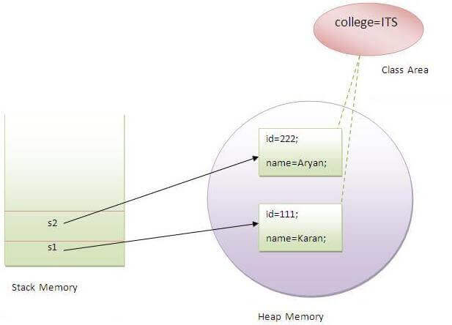

### Q) Why is the Java main method static?

Ans) It is because the object is not required to call a static method. If it were a non-static method,

creates an object first then call main() method that will lead the problem of extra memory allocation.

## 3) Java static block

* Is used to initialize the static data member.
* It is executed before the main method at the time of classloading.

### Example of static block

1. **class** A2{
2. **static**{System.out.println("static block is invoked");}
3. **public** **static** **void** main(String args[]){
4. System.out.println("Hello main");
5. }
6. }

# this keyword in Java

There can be a lot of usage of **Java this keyword**. In Java, this is a **reference variable** that refers to the current object.

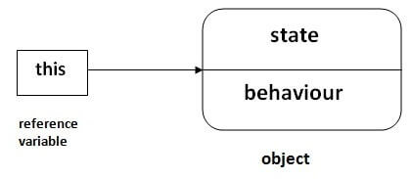

## Usage of Java this keyword

Here is given the 6 usage of java this keyword.

1. [this can be used to refer current class instance variable.](https://www.javatpoint.com/this1)
2. [this can be used to invoke current class method (implicitly)](https://www.javatpoint.com/this2)
3. [this() can be used to invoke current class constructor.](https://www.javatpoint.com/this3)
4. [this can be passed as an argument in the method call.](https://www.javatpoint.com/this4)
5. [this can be passed as argument in the constructor call.](https://www.javatpoint.com/this5)
6. [this can be used to return the current class instance from the method.](https://www.javatpoint.com/this6)

**Suggestion:** If you are beginner to java, lookup only three usages of this keyword.

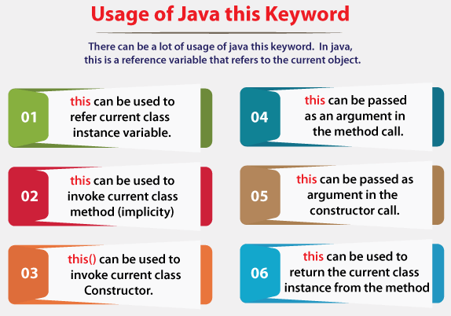

### 1) this: to refer current class instance variable

The this keyword can be used to refer current class instance variable. If there is ambiguity between the instance variables and parameters, this keyword resolves the problem of ambiguity.

30.1M

683

Features of Java - Javatpoint

#### Understanding the problem without this keyword

Let's understand the problem if we don't use this keyword by the example given below:

1. **class** Student{
2. **int** rollno;
3. String name;
4. **float** fee;
5. Student(**int** rollno,String name,**float** fee){
6. rollno=rollno;
7. name=name;
8. fee=fee;
9. }
10. **void** display(){System.out.println(rollno+" "+name+" "+fee);}
11. }
12. **class** TestThis1{
13. **public** **static** **void** main(String args[]){
14. Student s1=**new** Student(111,"ankit",5000f);
15. Student s2=**new** Student(112,"sumit",6000f);
16. s1.display();
17. s2.display();
18. }}

[**Test it Now**](https://www.javatpoint.com/opr/test.jsp?filename=TestThis1)

**Output:**

0 null 0.0

0 null 0.0

In the above example, parameters (formal arguments) and instance variables are same. So, we are using this keyword to distinguish local variable and instance variable.

#### Solution of the above problem by this keyword

1. **class** Student{
2. **int** rollno;
3. String name;
4. **float** fee;
5. Student(**int** rollno,String name,**float** fee){
6. **this**.rollno=rollno;
7. **this**.name=name;
8. **this**.fee=fee;
9. }
10. **void** display(){System.out.println(rollno+" "+name+" "+fee);}
11. }
13. **class** TestThis2{
14. **public** **static** **void** main(String args[]){
15. Student s1=**new** Student(111,"ankit",5000f);
16. Student s2=**new** Student(112,"sumit",6000f);
17. s1.display();
18. s2.display();
19. }}

[**Test it Now**](https://www.javatpoint.com/opr/test.jsp?filename=TestThis2)

**Output:**

111 ankit 5000.0

112 sumit 6000.0

If local variables(formal arguments) and instance variables are different, there is no need to use this keyword like in the following program:

#### Program where this keyword is not required

1. **class** Student{
2. **int** rollno;
3. String name;
4. **float** fee;
5. Student(**int** r,String n,**float** f){
6. rollno=r;
7. name=n;
8. fee=f;
9. }
10. **void** display(){System.out.println(rollno+" "+name+" "+fee);}
11. }
13. **class** TestThis3{
14. **public** **static** **void** main(String args[]){
15. Student s1=**new** Student(111,"ankit",5000f);
16. Student s2=**new** Student(112,"sumit",6000f);
17. s1.display();
18. s2.display();
19. }}

[**Test it Now**](https://www.javatpoint.com/opr/test.jsp?filename=TestThis3)

**Output:**

111 ankit 5000.0

112 sumit 6000.0

#### It is better approach to use meaningful names for variables. So we use same name for instance variables and parameters in real time, and always use this keyword.

### 2) this: to invoke current class method

You may invoke the method of the current class by using the this keyword. If you don't use the this keyword, compiler automatically adds this keyword while invoking the method. Let's see the example

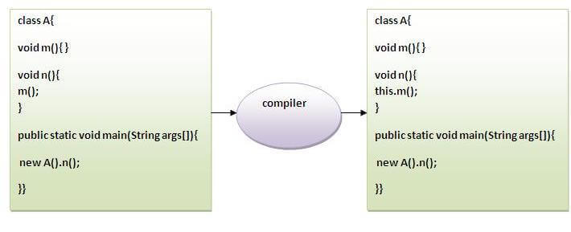

1. **class** A{
2. **void** m(){System.out.println("hello m");}
3. **void** n(){
4. System.out.println("hello n");
5. //m();//same as this.m()
6. **this**.m();
7. }
8. }
9. **class** TestThis4{
10. **public** **static** **void** main(String args[]){
11. A a=**new** A();
12. a.n();
13. }}

[**Test it Now**](https://www.javatpoint.com/opr/test.jsp?filename=TestThis4)

**Output:**

hello n

hello m

### 3) this() : to invoke current class constructor

The this() constructor call can be used to invoke the current class constructor. It is used to reuse the constructor. In other words, it is used for constructor chaining.

**Calling default constructor from parameterized constructor:**

1. **class** A{
2. A(){System.out.println("hello a");}
3. A(**int** x){
4. **this**();
5. System.out.println(x);
6. }
7. }
8. **class** TestThis5{
9. **public** **static** **void** main(String args[]){
10. A a=**new** A(10);
11. }}

[**Test it Now**](https://www.javatpoint.com/opr/test.jsp?filename=TestThis5)

**Output:**

hello a

10

**Calling parameterized constructor from default constructor:**

1. **class** A{
2. A(){
3. **this**(5);
4. System.out.println("hello a");
5. }
6. A(**int** x){
7. System.out.println(x);
8. }
9. }
10. **class** TestThis6{
11. **public** **static** **void** main(String args[]){
12. A a=**new** A();
13. }}

[**Test it Now**](https://www.javatpoint.com/opr/test.jsp?filename=TestThis6)

**Output:**

5

hello a

### Real usage of this() constructor call

The this() constructor call should be used to reuse the constructor from the constructor. It maintains the chain between the constructors i.e. it is used for constructor chaining. Let's see the example given below that displays the actual use of this keyword.

1. **class** Student{
2. **int** rollno;
3. String name,course;
4. **float** fee;
5. Student(**int** rollno,String name,String course){
6. **this**.rollno=rollno;
7. **this**.name=name;
8. **this**.course=course;
9. }
10. Student(**int** rollno,String name,String course,**float** fee){
11. **this**(rollno,name,course);//reusing constructor
12. **this**.fee=fee;
13. }
14. **void** display(){System.out.println(rollno+" "+name+" "+course+" "+fee);}
15. }
16. **class** TestThis7{
17. **public** **static** **void** main(String args[]){
18. Student s1=**new** Student(111,"ankit","java");
19. Student s2=**new** Student(112,"sumit","java",6000f);
20. s1.display();
21. s2.display();
22. }}

[**Test it Now**](https://www.javatpoint.com/opr/test.jsp?filename=TestThis7)

**Output:**

111 ankit java 0.0

112 sumit java 6000.0

#### Rule: Call to this() must be the first statement in constructor.

1. **class** Student{
2. **int** rollno;
3. String name,course;
4. **float** fee;
5. Student(**int** rollno,String name,String course){
6. **this**.rollno=rollno;
7. **this**.name=name;
8. **this**.course=course;
9. }
10. Student(**int** rollno,String name,String course,**float** fee){
11. **this**.fee=fee;
12. **this**(rollno,name,course);//C.T.Error
13. }
14. **void** display(){System.out.println(rollno+" "+name+" "+course+" "+fee);}
15. }
16. **class** TestThis8{
17. **public** **static** **void** main(String args[]){
18. Student s1=**new** Student(111,"ankit","java");
19. Student s2=**new** Student(112,"sumit","java",6000f);
20. s1.display();
21. s2.display();
22. }}

[**Test it Now**](https://www.javatpoint.com/opr/test.jsp?filename=TestThis8)

**Output:**

Compile Time Error: Call to this must be first statement in constructor

### 4) this: to pass as an argument in the method

The this keyword can also be passed as an argument in the method. It is mainly used in the event handling. Let's see the example:

1. **class** S2{
2. **void** m(S2 obj){
3. System.out.println("method is invoked");
4. }
5. **void** p(){
6. m(**this**);
7. }
8. **public** **static** **void** main(String args[]){
9. S2 s1 = **new** S2();
10. s1.p();
11. }
12. }

[**Test it Now**](https://www.javatpoint.com/opr/test.jsp?filename=S2)

**Output:**

method is invoked

### Application of this that can be passed as an argument:

In event handling (or) in a situation where we have to provide reference of a class to another one. It is used to reuse one object in many methods.

### 5) this: to pass as argument in the constructor call

We can pass the this keyword in the constructor also. It is useful if we have to use one object in multiple classes. Let's see the example:

1. **class** B{
2. A4 obj;
3. B(A4 obj){
4. **this**.obj=obj;
5. }
6. **void** display(){
7. System.out.println(obj.data);//using data member of A4 class
8. }
9. }
11. **class** A4{
12. **int** data=10;
13. A4(){
14. B b=**new** B(**this**);
15. b.display();
16. }
17. **public** **static** **void** main(String args[]){
18. A4 a=**new** A4();
19. }
20. }

[**Test it Now**](https://www.javatpoint.com/opr/test.jsp?filename=A4)

Output:10

### 6) this keyword can be used to return current class instance

We can return this keyword as an statement from the method. In such case, return type of the method must be the class type (non-primitive). Let's see the example:

### Syntax of this that can be returned as a statement

1. return_type method_name(){
2. **return** **this**;
3. }

### Example of this keyword that you return as a statement from the method

1. **class** A{
2. A getA(){
3. **return** **this**;
4. }
5. **void** msg(){System.out.println("Hello java");}
6. }
7. **class** Test1{
8. **public** **static** **void** main(String args[]){
9. **new** A().getA().msg();
10. }
11. }

[**Test it Now**](https://www.javatpoint.com/opr/test.jsp?filename=Test1)

**Output:**

Hello java

### Proving this keyword

Let's prove that this keyword refers to the current class instance variable. In this program, we are printing the reference variable and this, output of both variables are same.

1. **class** A5{
2. **void** m(){
3. System.out.println(**this**);//prints same reference ID
4. }
5. **public** **static** **void** main(String args[]){
6. A5 obj=**new** A5();
7. System.out.println(obj);//prints the reference ID
8. obj.m();
9. }
10. }

## Naming Conventions of the Different Identifiers

### The following table shows the popular conventions used for the different identifiers

|  |  |  |
| --- | --- | --- |
| **Identifiers Type** | **Naming Rules** | **Examples** |
| Class | It should start with the uppercase letter. It should be a noun such as Color, Button, System, Thread, etc. Use appropriate words, instead of acronyms. | public class **Employee** { //code snippet } |
| Interface | It should start with the uppercase letter. It should be an adjective such as Runnable, Remote, ActionListener. Use appropriate words, instead of acronyms. | interface **Printable** { //code snippet } |
| Method | It should start with lowercase letter. It should be a verb such as main(), print(), println(). If the name contains multiple words, start it with a lowercase letter followed by an uppercase letter such as actionPerformed(). | class Employee { // method void **draw()** { //code snippet } } |
| Variable | It should start with a lowercase letter such as id, name. It should not start with the special characters like & (ampersand), $ (dollar), _ (underscore). If the name contains multiple words, start it with the lowercase letter followed by an uppercase letter such as firstName, lastName. Avoid using one-character variables such as x, y, z. | class Employee { // variable int **id**; //code snippet } |
| Package | It should be a lowercase letter such as java, lang. If the name contains multiple words, it should be separated by dots (.) such as java.util, java.lang. | //package package **com.javatpoint;** class Employee { //code snippet } |
| Constant | It should be in uppercase letters such as RED, YELLOW. If the name contains multiple words, it should be separated by an underscore(_) such as MAX_PRIORITY. It may contain digits but not as the first letter. | class Employee { //constant static final int **MIN_AGE** = 18; //code snippet } |

.

## OOPs (Object-Oriented Programming System)

**Object** means a real-world entity such as a pen, chair, table, computer, watch, etc. **Object-Oriented Programming** is a methodology or paradigm to design a program using classes and objects. It simplifies software development and maintenance by providing some concepts:

* [Object](https://www.javatpoint.com/object-and-class-in-java)
* Class
* [Inheritance](https://www.javatpoint.com/inheritance-in-java)
* [Polymorphism](https://www.javatpoint.com/runtime-polymorphism-in-java)
* [Abstraction](https://www.javatpoint.com/abstract-class-in-java)
* [Encapsulation](https://www.javatpoint.com/encapsulation)
* [Inheritance](https://www.javatpoint.com/inheritance-in-java):

**Inheritance in Java** is a mechanism in which one object acquires all the properties and behaviors of a parent object. It is an important part of [OOPs](https://www.javatpoint.com/java-oops-concepts)

(Object Oriented programming system).

The idea behind inheritance in Java is that you can create new [classes](https://www.javatpoint.com/object-and-class-in-java)

that are built upon existing classes.

### Why use inheritance in java

* For [Method Overriding](https://www.javatpoint.com/method-overriding-in-java)

(so [runtime polymorphism](https://www.javatpoint.com/runtime-polymorphism-in-java)

can be achieved).

* For Code Reusability.

### Terms used in Inheritance

* **Class:** A class is a group of objects which have common properties. It is a template or blueprint from which objects are created.
* **Sub Class/Child Class:** Subclass is a class which inherits the other class. It is also called a derived class, extended class, or child class.
* **Super Class/Parent Class:** Superclass is the class from where a subclass inherits the features. It is also called a base class or a parent class.
* **Reusability:** As the name specifies, reusability is a mechanism which facilitates you to reuse the fields and methods of the existing class when you create a new class. You can use the same fields and methods already defined in the previous class.

1. **class** Subclass-name **extends** Superclass-name
2. {
3. //methods and fields
4. }
5. **class** Employee{
6. **float** salary=40000;
7. }
8. **class** Programmer **extends** Employee{
9. **int** bonus=10000;
10. **public** **static** **void** main(String args[]){
11. Programmer p=**new** Programmer();
12. System.out.println("Programmer salary is:"+p.salary);
13. System.out.println("Bonus of Programmer is:"+p.bonus);
14. }
15. }
16. **class** Animal{
17. **void** eat(){System.out.println("eating...");}
18. }
19. **class** Dog **extends** Animal{
20. **void** bark(){System.out.println("barking...");}
21. }
22. **class** BabyDog **extends** Dog{
23. **void** weep(){System.out.println("weeping...");}
24. }
25. **class** TestInheritance2{
26. **public** **static** **void** main(String args[]){
27. BabyDog d=**new** BabyDog();
28. d.weep();
29. d.bark();
30. d.eat();
31. }}

Aggregation in Java

If a class have an entity reference, it is known as Aggregation. Aggregation represents HAS-A relationship.

Consider a situation, Employee object contains many informations such as id, name, emailId etc. It contains one more object named address, which contains its own informations such as city, state, country, zipcode etc. as given below.

1. **class** Employee{
2. **int** id;
3. String name;
4. Address address;//Address is a class
5. ...
6. }

In such case, Employee has an entity reference address, so relationship is Employee HAS-A address.

Why use Aggregation?

* For Code Reusability.

#### Address.java

1. **public** **class** Address {
2. String city,state,country;
4. **public** Address(String city, String state, String country) {
5. **this**.city = city;
6. **this**.state = state;
7. **this**.country = country;
8. }
10. }

#### Emp.java

1. **public** **class** Emp {
2. **int** id;
3. String name;
4. Address address;
6. **public** Emp(**int** id, String name,Address address) {
7. **this**.id = id;
8. **this**.name = name;
9. **this**.address=address;
10. }
12. **void** display(){
13. System.out.println(id+" "+name);
14. System.out.println(address.city+" "+address.state+" "+address.country);
15. }
17. **public** **static** **void** main(String[] args) {
18. Address address1=**new** Address("gzb","UP","india");
19. Address address2=**new** Address("gno","UP","india");
21. Emp e=**new** Emp(111,"varun", address1);
22. Emp e2=**new** Emp(112,"arun",address2);
24. e.display();
25. e2.display();
27. }
28. }

* [Polymorphism](https://www.javatpoint.com/runtime-polymorphism-in-java):

# Polymorphism in Java

**Polymorphism in Java** is a concept by which we can perform a single action in different ways. Polymorphism is derived from 2 Greek words: poly and morphs. The word "poly" means many and "morphs" means forms. So polymorphism means many forms.

There are two types of polymorphism in Java: compile-time polymorphism and runtime polymorphism. We can perform polymorphism in java by method overloading and method overriding.

# Method Overloading in Java

If a [class](https://www.javatpoint.com/object-and-class-in-java) has multiple methods having same name but different in parameters, it is known as **Method Overloading**.

If we have to perform only one operation, having same name of the methods increases the readability of the [program](https://www.javatpoint.com/java-programs).

Suppose you have to perform addition of the given numbers but there can be any number of arguments, if you write the method such as a(int,int) for two parameters, and b(int,int,int) for three parameters then it may be difficult for you as well as other programmers to understand the behavior of the method because its name differs.

So, we perform method overloading to figure out the program quickly.

OOPs Concepts in Java

## Advantage of method overloading

Method overloading increases the readability of the program.

### Different ways to overload the method

There are two ways to overload the method in java

1. By changing number of arguments
2. By changing the data type

#### In Java, Method Overloading is not possible by changing the return type of the method only.

1. **class** Adder{
2. **static** **int** add(**int** a,**int** b){
3. **return** a+b;
4. }
5. **static** **int** add(**int** a,**int** b,**int** c){
6. **return** a+b+c;
7. }
8. }
9. **class** TestOverloading1{
10. **public** **static** **void** main(String[] args){
11. System.out.println(Adder.add(11,11));
12. System.out.println(Adder.add(11,11,11));
13. }}
14. **class** Adder{
15. **static** **int** add(**int** a, **int** b){
16. **return** a+b;
17. }
18. **static** **double** add(**double** a, **double** b){
19. **return** a+b;
20. }
21. }
22. **class** TestOverloading2{
23. **public** **static** **void** main(String[] args){
24. System.out.println(Adder.add(11,11));
25. System.out.println(Adder.add(12.3,12.6));
26. }}

# Method Overriding in Java

If subclass (child class) has the same method as declared in the parent class, it is known as **method overriding in Java**.

In other words, If a subclass provides the specific implementation of the method that has been declared by one of its parent class, it is known as method overriding.

### Usage of Java Method Overriding

* Method overriding is used to provide the specific implementation of a method which is already provided by its superclass.
* Method overriding is used for runtime polymorphism

#### Rules for Java Method Overriding

1. The method must have the same name as in the parent class
2. The method must have the same parameter as in the parent class.
3. There must be an IS-A relationship (inheritance).
4. **class** Vehicle{
5. //defining a method
6. **void** run(){
7. System.out.println("Vehicle is running");
8. }
9. }
10. //Creating a child class
11. **class** Bike2 **extends** Vehicle{
12. //defining the same method as in the parent class
13. **void** run(){
14. System.out.println("Bike is running safely");
15. }
17. **public** **static** **void** main(String args[]){
18. Bike2 obj = **new** Bike2();//creating object
19. obj.run();//calling method
20. }
21. }

## Usage of Java super Keyword

1. super can be used to refer immediate parent class instance variable.
2. super can be used to invoke immediate parent class method.
3. super() can be used to invoke immediate parent class constructor.

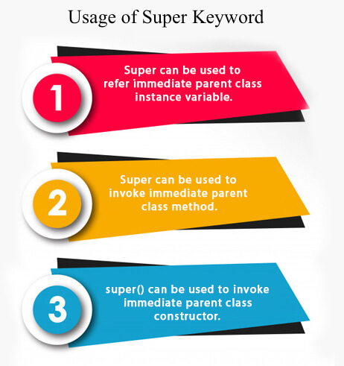

## 1) super is used to refer immediate parent class instance variable.

We can use super keyword to access the data member or field of parent class. It is used if parent class and child class have same fields.

1. **class** Animal{
2. String color="white";
3. }
4. **class** Dog **extends** Animal{
5. String color="black";
6. **void** printColor(){
7. System.out.println(color);//prints color of Dog class
8. System.out.println(**super**.color);//prints color of Animal class
9. }
10. }
11. **class** TestSuper1{
12. **public** **static** **void** main(String args[]){
13. Dog d=**new** Dog();
14. d.printColor();
15. }}

The **final keyword** in java is used to restrict the user. The java final keyword can be used in many context. Final can be:

1. variable
2. method
3. class
4. **package** com.demo5;
5. **final** **class** Bike10{
6. **final** **int** speedlimit=90;//final variable
7. **final** **void** run(){
8. speedlimit=400;
9. }
10. }
11. **public** **class** Sample **extends** Bike10 {
12. **void** run(){
13. speedlimit=400;
14. }
15. **public** **static** **void** main(String[] args) {
16. Sample sam=**new** Sample();

19. }
20. }

## 1) Java final variable

If you make any variable as final, you cannot change the value of final variable(It will be constant).

## 2) Java final method

If you make any method as final, you cannot override it.

## 3) Java final class

If you make any class as final, you cannot extend it.

* [Abstraction](https://www.javatpoint.com/abstract-class-in-java):

### Abstraction in Java

**Abstraction** is a process of hiding the implementation details and showing only functionality to the user.

Another way, it shows only essential things to the user and hides the internal details, for example, sending SMS where you type the text and send the message. You don't know the internal processing about the message delivery.

There are two ways to achieve abstraction in java

1. Abstract class (0 to 100%)
2. Interface (100%)

### Abstract class in Java

A class which is declared as abstract is known as an **abstract class**. It can have abstract and non-abstract methods. It needs to be extended and its method implemented. It cannot be instantiated.

#### Points to Remember

* An abstract class must be declared with an abstract keyword.
* It can have abstract and non-abstract methods.
* It cannot be instantiated.
* It can have [constructors](https://www.javatpoint.com/java-constructor) and static methods also.
* It can have final methods which will force the subclass not to change the body of the method.

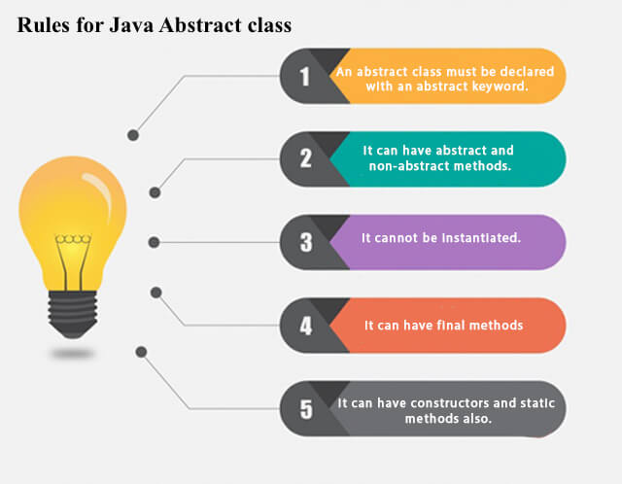

**Example of abstract class**

1. **abstract** **class** A{}

### Abstract Method in Java

A method which is declared as abstract and does not have implementation is known as an abstract method.

**Example of abstract method**

1. **abstract** **void** printStatus();//no method body and abstract

### Example of Abstract class that has an abstract method

In this example, Bike is an abstract class that contains only one abstract method run. Its implementation is provided by the Honda class.

1. **abstract** **class** Bike{
2. **abstract** **void** run();
3. }
4. **class** Honda4 **extends** Bike{
5. **void** run(){System.out.println("running safely");}
6. **public** **static** **void** main(String args[]){
7. Bike obj = **new** Honda4();
8. obj.run();
9. }
10. }

[**Test it Now**](https://www.javatpoint.com/opr/test.jsp?filename=Honda4)

running safely

### Understanding the real scenario of Abstract class

In this example, Shape is the abstract class, and its implementation is provided by the Rectangle and Circle classes.

Mostly, we don't know about the implementation class (which is hidden to the end user), and an object of the implementation class is provided by the **factory method**.

A **factory method** is a method that returns the instance of the class. We will learn about the factory method later.

In this example, if you create the instance of Rectangle class, draw() method of Rectangle class will be invoked.

*File: TestAbstraction1.java*

1. **abstract** **class** Shape{
2. **abstract** **void** draw();
3. }
4. //In real scenario, implementation is provided by others i.e. unknown by end user
5. **class** Rectangle **extends** Shape{
6. **void** draw(){System.out.println("drawing rectangle");}
7. }
8. **class** Circle1 **extends** Shape{
9. **void** draw(){System.out.println("drawing circle");}
10. }
11. //In real scenario, method is called by programmer or user
12. **class** TestAbstraction1{
13. **public** **static** **void** main(String args[]){
14. Shape s=**new** Circle1();//In a real scenario, object is provided through method, e.g., getShape() method
15. s.draw();
16. }
17. }

[**Test it Now**](https://www.javatpoint.com/opr/test.jsp?filename=TestAbstraction1)

drawing circle

### Another example of Abstract class in java

*File: TestBank.java*

1. **abstract** **class** Bank{
2. **abstract** **int** getRateOfInterest();
3. }
4. **class** SBI **extends** Bank{
5. **int** getRateOfInterest(){**return** 7;}
6. }
7. **class** PNB **extends** Bank{
8. **int** getRateOfInterest(){**return** 8;}
9. }
11. **class** TestBank{
12. **public** **static** **void** main(String args[]){
13. Bank b;
14. b=**new** SBI();
15. System.out.println("Rate of Interest is: "+b.getRateOfInterest()+" %");
16. b=**new** PNB();
17. System.out.println("Rate of Interest is: "+b.getRateOfInterest()+" %");
18. }}

[**Test it Now**](https://www.javatpoint.com/opr/test.jsp?filename=TestBank)

Rate of Interest is: 7 %

Rate of Interest is: 8 %

### Abstract class having constructor, data member and methods

An abstract class can have a data member, abstract method, method body (non-abstract method), constructor, and even main() method.

*File: TestAbstraction2.java*

1. //Example of an abstract class that has abstract and non-abstract methods
2. **abstract** **class** Bike{
3. Bike(){System.out.println("bike is created");}
4. **abstract** **void** run();
5. **void** changeGear(){System.out.println("gear changed");}
6. }
7. //Creating a Child class which inherits Abstract class
8. **class** Honda **extends** Bike{
9. **void** run(){System.out.println("running safely..");}
10. }
11. //Creating a Test class which calls abstract and non-abstract methods
12. **class** TestAbstraction2{
13. **public** **static** **void** main(String args[]){
14. Bike obj = **new** Honda();
15. obj.run();
16. obj.changeGear();
17. }
18. }

[**Test it Now**](https://www.javatpoint.com/opr/test.jsp?filename=TestAbstraction2)

bike is created

running safely..

gear changed

#### Rule: If there is an abstract method in a class, that class must be abstract.

1. **class** Bike12{
2. **abstract** **void** run();
3. }

[**Test it Now**](https://www.javatpoint.com/opr/test.jsp?filename=Bike12)

compile time error

#### Rule: If you are extending an abstract class that has an abstract method, you must either provide the implementation of the method or make this class abstract.

### Another real scenario of abstract class

The abstract class can also be used to provide some implementation of the [interface](https://www.javatpoint.com/interface-in-java). In such case, the end user may not be forced to override all the methods of the interface.

#### Note: If you are beginner to java, learn interface first and skip this example.

1. **interface** A{
2. **void** a();
3. **void** b();
4. **void** c();
5. **void** d();
6. }
8. **abstract** **class** B **implements** A{
9. **public** **void** c(){System.out.println("I am c");}
10. }
12. **class** M **extends** B{
13. **public** **void** a(){System.out.println("I am a");}
14. **public** **void** b(){System.out.println("I am b");}
15. **public** **void** d(){System.out.println("I am d");}
16. }
18. **class** Test5{
19. **public** **static** **void** main(String args[]){
20. A a=**new** M();
21. a.a();
22. a.b();
23. a.c();
24. a.d();
25. }}

[**Test it Now**](https://www.javatpoint.com/opr/test.jsp?filename=Test5)

Output:I am a

I am b

I am c

I am d

Example:

**package** com.cognizant;

/*o An abstract class must be declared with an abstract keyword.

o It can have abstract and non-abstract methods.

o It cannot be instantiated.

o It can have constructors and static methods also.

o It can have final methods which will force the subclass not to change the body of the method.*/

**abstract** **class** AbstractExample {

AbstractExample()

{

System.***out***.println("constructor");

}

**final** **void** demo()

{

System.***out***.println("finla method");

}

**abstract** **void** sum();

**void** normalMethod() {

System.***out***.println("normal methods");

}

}

**package** com.cognizant;

**public** **class** AbstractMain **extends** AbstractExample{

@Override

**void** sum() {

System.***out***.println("implementation");

}

**public** **static** **void** main(String[] args) {

AbstractMain am=**new** AbstractMain();

am.sum();

am.normalMethod();

am.demo();

}

}

Interface:

1. An **interface in Java** is a blueprint of a class. It has static constants and abstract methods.
2. The interface in Java is a mechanism to achieve [*abstraction*](https://www.javatpoint.com/abstract-class-in-java). There can be only abstract methods in the Java interface, not method body. It is used to achieve abstraction and multiple [inheritance in Java](https://www.javatpoint.com/inheritance-in-java).

## Why use Java interface?

There are mainly three reasons to use interface. They are given below.

* It is used to achieve abstraction.
* By interface, we can support the functionality of multiple inheritance.
* It can be used to achieve loose coupling.

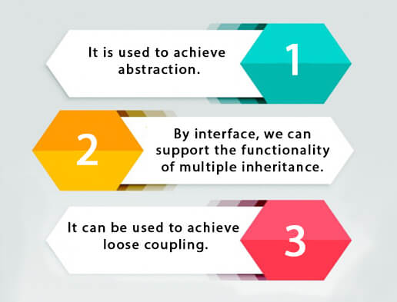

## How to declare an interface?

An interface is declared by using the interface keyword. It provides total abstraction; means all the methods in an interface are declared with the empty body, and all the fields are public, static and final by default. A class that implements an interface must implement all the methods declared in the interface.

### Syntax:

1. **interface** <interface_name>{
3. // declare constant fields
4. // declare methods that abstract
5. // by default.
6. }
7. **interface** printable{
8. **abstract void** print();
9. }
10. **class** A6 **implements** printable{
11. **public** **void** print(){System.out.println("Hello");}
13. **public** **static** **void** main(String args[]){
14. A6 obj = **new** A6();
15. obj.print();
16. }
17. }

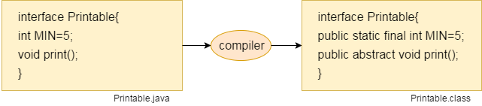

#### The relationship between classes and interfaces

As shown in the figure given below, a class extends another class, an interface extends another interface, but a **class implements an interface**.

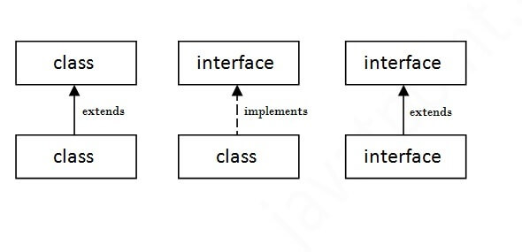

## Java Interface Example

In this example, the Printable interface has only one method, and its implementation is provided in the A6 class.

1. **interface** printable{
2. **void** print();
3. }
4. **class** A6 **implements** printable{
5. **public** **void** print(){System.out.println("Hello");}
7. **public** **static** **void** main(String args[]){
8. A6 obj = **new** A6();
9. obj.print();
10. }
11. }

[**Test it Now**](https://www.javatpoint.com/opr/test.jsp?filename=A6)

Output:

Hello

## Java Interface Example: Drawable

In this example, the Drawable interface has only one method. Its implementation is provided by Rectangle and Circle classes. In a real scenario, an interface is defined by someone else, but its implementation is provided by different implementation providers. Moreover, it is used by someone else. The implementation part is hidden by the user who uses the interface.

*File: TestInterface1.java*

1. //Interface declaration: by first user
2. **interface** Drawable{
3. **void** draw();
4. }
5. //Implementation: by second user
6. **class** Rectangle **implements** Drawable{
7. **public** **void** draw(){System.out.println("drawing rectangle");}
8. }
9. **class** Circle **implements** Drawable{
10. **public** **void** draw(){System.out.println("drawing circle");}
11. }
12. //Using interface: by third user
13. **class** TestInterface1{
14. **public** **static** **void** main(String args[]){
15. Drawable d=**new** Circle();//In real scenario, object is provided by method e.g. getDrawable()
16. d.draw();
17. }}

## Java Interface Example: Bank

Let's see another example of java interface which provides the implementation of Bank interface.

*File: TestInterface2.java*

1. **interface** Bank{
2. **float** rateOfInterest();
3. }
4. **class** SBI **implements** Bank{
5. **public** **float** rateOfInterest(){**return** 9.15f;}
6. }
7. **class** PNB **implements** Bank{
8. **public** **float** rateOfInterest(){**return** 9.7f;}
9. }
10. **class** TestInterface2{
11. **public** **static** **void** main(String[] args){
12. Bank b=**new** SBI();
13. System.out.println("ROI: "+b.rateOfInterest());
14. }}

[**Test it Now**](https://www.javatpoint.com/opr/test.jsp?filename=TestInterface2)

Output:

ROI: 9.15

## Multiple inheritance in Java by interface

If a class implements multiple interfaces, or an interface extends multiple interfaces, it is known as multiple inheritance.

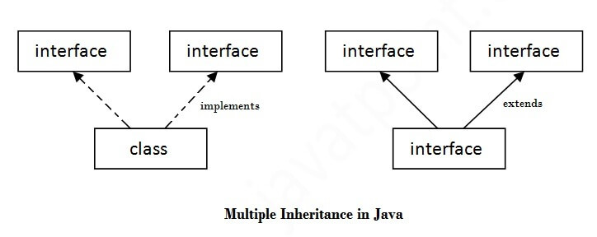

1. **interface** Printable{
2. **void** print();
3. }
4. **interface** Showable{
5. **void** show();
6. }
7. **class** A7 **implements** Printable,Showable{
8. **public** **void** print(){System.out.println("Hello");}
9. **public** **void** show(){System.out.println("Welcome");}
11. **public** **static** **void** main(String args[]){
12. A7 obj = **new** A7();
13. obj.print();
14. obj.show();
15. }
16. }

[**Test it Now**](https://www.javatpoint.com/opr/test.jsp?filename=A7)

Output:Hello

Welcome

## Q) Multiple inheritance is not supported through class in java, but it is possible by an interface, why?

As we have explained in the inheritance chapter, multiple inheritance is not supported in the case of [class](https://www.javatpoint.com/object-and-class-in-java) because of ambiguity. However, it is supported in case of an interface because there is no ambiguity. It is because its implementation is provided by the implementation class. For example:

1. **interface** Printable{
2. **void** print();
3. }
4. **interface** Showable{
5. **void** print();
6. }
8. **class** TestInterface3 **implements** Printable, Showable{
9. **public** **void** print(){System.out.println("Hello");}
10. **public** **static** **void** main(String args[]){
11. TestInterface3 obj = **new** TestInterface3();
12. obj.print();
13. }
14. }

[**Test it Now**](https://www.javatpoint.com/opr/test.jsp?filename=TestInterface3)

Output:

Hello

As you can see in the above example, Printable and Showable interface have same methods but its implementation is provided by class TestTnterface1, so there is no ambiguity.

## Interface inheritance

A class implements an interface, but one interface extends another interface.

1. **interface** Printable{
2. **void** print();
3. }
4. **interface** Showable **extends** Printable{
5. **void** show();
6. }
7. **class** TestInterface4 **implements** Showable{
8. **public** **void** print(){System.out.println("Hello");}
9. **public** **void** show(){System.out.println("Welcome");}
11. **public** **static** **void** main(String args[]){
12. TestInterface4 obj = **new** TestInterface4();
13. obj.print();
14. obj.show();
15. }
16. }

[**Test it Now**](https://www.javatpoint.com/opr/test.jsp?filename=TestInterface4)

Output:

Hello

Welcome

# Difference between abstract class and interface

Abstract class and interface both are used to achieve abstraction where we can declare the abstract methods. Abstract class and interface both can't be instantiated.

But there are many differences between abstract class and interface that are given below.

|  |  |
| --- | --- |
| **Abstract class** | **Interface** |
| 1) Abstract class can **have abstract and non-abstract** methods. | Interface can have **only abstract** methods. Since Java 8, it can have **default and static methods** also. |
| 2) Abstract class **doesn't support multiple inheritance**. | Interface **supports multiple inheritance**. |
| 3) Abstract class **can have final, non-final, static and non-static variables**. | Interface has **only static and final variables**. |
| 4) Abstract class **can provide the implementation of interface**. | Interface **can't provide the implementation of abstract class**. |
| 5) The **abstract keyword** is used to declare abstract class. | The **interface keyword** is used to declare interface. |
| 6) An **abstract class** can extend another Java class and implement multiple Java interfaces. | An **interface** can extend another Java interface only. |
| 7) An **abstract class** can be extended using keyword "extends". | An **interface** can be implemented using keyword "implements". |
| 8) A Java **abstract class** can have class members like private, protected, etc. | Members of a Java interface are public by default. |
| 9)**Example:** public abstract class Shape{ public abstract void draw(); } | **Example:** public interface Drawable{ void draw(); } |

A **java package** is a group of similar types of classes, interfaces and sub-packages.

Package in java can be categorized in two form, built-in package and user-defined package.

There are many built-in packages such as java, lang, awt, javax, swing, net, io, util, sql etc.

Here, we will have the detailed learning of creating and using user-defined packages.

Hello Java Program for Beginners

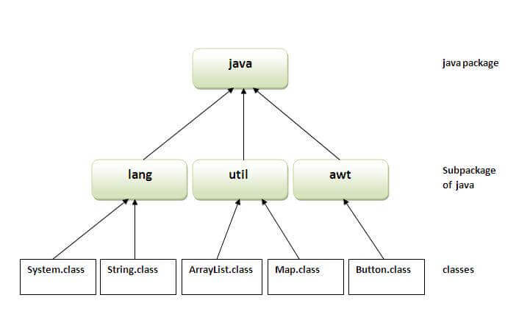

There are four types of Java access modifiers:

1. **Private**: The access level of a private modifier is only within the class. It cannot be accessed from outside the class.
2. **Default**: The access level of a default modifier is only within the package. It cannot be accessed from outside the package. If you do not specify any access level, it will be the default.
3. **Protected**: The access level of a protected modifier is within the package and outside the package through child class. If you do not make the child class, it cannot be accessed from outside the package.
4. **Public**: The access level of a public modifier is everywhere. It can be accessed from within the class, outside the class, within the package and outside the package.

# Encapsulation in Java

**Encapsulation in Java** is a process of wrapping code and data together into a single unit, for example, a capsule which is mixed of several medicines.



We can create a fully encapsulated class in Java by making all the data members of the class private. Now we can use setter and getter methods to set and get the data in it.

The **Java Bean** class is the example of a fully encapsulated class.

### Advantage of Encapsulation in Java

By providing only a setter or getter method, you can make the class **read-only or write-only**. In other words, you can skip the getter or setter methods.

Simple Example of Encapsulation in Java

Let's see the simple example of encapsulation that has only one field with its setter and getter methods.

*File: Student.java*

1. //A Java class which is a fully encapsulated class.
2. //It has a private data member and getter and setter methods.
3. **package** com.javatpoint;
4. **public** **class** Student{
5. //private data member
6. **private** String name;
7. //getter method for name
8. **public** String getName(){
9. **return** name;
10. }
11. //setter method for name
12. **public** **void** setName(String name){
13. **this**.name=name
14. }
15. }

*File: Test.java*

1. //A Java class to test the encapsulated class.
2. **package** com.javatpoint;
3. **class** Test{
4. **public** **static** **void** main(String[] args){
5. //creating instance of the encapsulated class
6. Student s=**new** Student();
7. //setting value in the name member
8. s.setName("vijay");
9. //getting value of the name member
10. System.out.println(s.getName());
11. }
12. }

# Java Arrays

Normally, an array is a collection of similar type of elements which has contiguous memory location.

**Java array** is an object which contains elements of a similar data type. Additionally, The elements of an array are stored in a contiguous memory location. It is a data structure where we store similar elements. We can store only a fixed set of elements in a Java array.

Array in Java is index-based, the first element of the array is stored at the 0th index, 2nd element is stored on 1st index and so on.

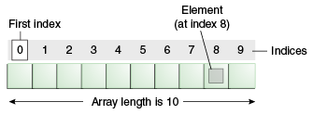

Disadvantages

* **Size Limit:** We can store only the fixed size of elements in the array. It doesn't grow its size at runtime. To solve this problem, collection framework is used in Java which grows automatically.

Types of Array in java

There are two types of array.

* Single Dimensional Array
* Multidimensional Array
* **class** Testarray{
* **public** **static** **void** main(String args[]){
* **int** a[]=**new** **int**[5];//declaration and instantiation
* a[0]=10;//initialization
* a[1]=20;
* a[2]=70;
* a[3]=40;
* a[4]=50;
* //traversing array
* **for**(**int** i=0;i<a.length;i++)//length is the property of array
* System.out.println(a[i]);
* }}

1. **class** Testarray1{
2. **public** **static** **void** main(String args[]){
3. **int** a[]={33,3,4,5};//declaration, instantiation and initialization
4. //printing array
5. **for**(**int** i=0;i<a.length;i++)//length is the property of array
6. System.out.println(a[i]);
7. }}

**Example to instantiate Multidimensional Array in Java**

1. **int**[][] arr=**new** **int**[3][3];//3 row and 3 column

**Example to initialize Multidimensional Array in Java**

1. arr[0][0]=1;
2. arr[0][1]=2;
3. arr[0][2]=3;
4. arr[1][0]=4;
5. arr[1][1]=5;
6. arr[1][2]=6;
7. arr[2][0]=7;
8. arr[2][1]=8;
9. arr[2][2]=9;

### Example of Multidimensional Java Array

Let's see the simple example to declare, instantiate, initialize and print the 2Dimensional array.

1. //Java Program to illustrate the use of multidimensional array
2. **class** Testarray3{
3. **public** **static** **void** main(String args[]){
4. //declaring and initializing 2D array
5. **int** arr[][]={{1,2,3},{2,4,5},{4,4,5}};
6. //printing 2D array
7. **for**(**int** i=0;i<3;i++){
8. **for**(**int** j=0;j<3;j++){
9. System.out.print(arr[i][j]+" ");
10. }
11. System.out.println();
12. }
13. }}

# Object class in Java

The **Object class** is the parent class of all the classes in java by default. In other words, it is the topmost class of java.

### Methods of Object class

|  |
| --- |
| The Object class provides many methods. They are as follows: |

|  |  |
| --- | --- |
| **Method** | **Description** |
| public final Class getClass() | returns the Class class object of this object. The Class class can further be used to get the metadata of this class. |
| public int hashCode() | returns the hashcode number for this object. |
| public boolean equals(Object obj) | compares the given object to this object. |
| protected Object clone() throws CloneNotSupportedException | creates and returns the exact copy (clone) of this object. |
| public String toString() | returns the string representation of this object. |
| public final void notify() | wakes up single thread, waiting on this object's monitor. |
| public final void notifyAll() | wakes up all the threads, waiting on this object's monitor. |
| public final void wait(long timeout)throws InterruptedException | causes the current thread to wait for the specified milliseconds, until another thread notifies (invokes notify() or notifyAll() method). |
| public final void wait(long timeout,int nanos)throws InterruptedException | causes the current thread to wait for the specified milliseconds and nanoseconds, until another thread notifies (invokes notify() or notifyAll() method). |
| public final void wait()throws InterruptedException | causes the current thread to wait, until another thread notifies (invokes notify() or notifyAll() method). |
| protected void finalize()throws Throwable | is invoked by the garbage collector before object is being garbage collected. |

# Wrapper classes in Java

The **wrapper class in Java** provides the mechanism to convert primitive into object and object into primitive.

Since J2SE 5.0, **autoboxing** and **unboxing** feature convert primitives into objects and objects into primitives automatically. The automatic conversion of primitive into an object is known as autoboxing and vice-versa unboxing.

|  |  |
| --- | --- |
| **Primitive Type** | **Wrapper class** |
| Boolean | [Boolean](https://www.javatpoint.com/java-boolean) |
| Char | [Character](https://www.javatpoint.com/post/java-character) |
| Byte | [Byte](https://www.javatpoint.com/java-byte) |
| Short | [Short](https://www.javatpoint.com/java-short) |
| Int | [Integer](https://www.javatpoint.com/java-integer) |
| Long | [Long](https://www.javatpoint.com/java-long) |
| Float | [Float](https://www.javatpoint.com/java-float) |
| Double | [Double](https://www.javatpoint.com/java-double) |

## Autoboxing

The automatic conversion of primitive data type into its corresponding wrapper class is known as autoboxing, for example, byte to Byte, char to Character, int to Integer, long to Long, float to Float, boolean to Boolean, double to Double, and short to Short.

Since Java 5, we do not need to use the valueOf() method of wrapper classes to convert the primitive into objects.

**Wrapper class Example: Primitive to Wrapper**

1. //Java program to convert primitive into objects
2. //Autoboxing example of int to Integer
3. **public** **class** WrapperExample1{
4. **public** **static** **void** main(String args[]){
5. //Converting int into Integer
6. **int** a=20;
7. Integer i=Integer.valueOf(a);//converting int into Integer explicitly
8. Integer j=a;//autoboxing, now compiler will write Integer.valueOf(a) internally
10. System.out.println(a+" "+i+" "+j);
11. }}

Output:

20 20 20

## Unboxing

The automatic conversion of wrapper type into its corresponding primitive type is known as unboxing. It is the reverse process of autoboxing. Since Java 5, we do not need to use the intValue() method of wrapper classes to convert the wrapper type into primitives.

**Wrapper class Example: Wrapper to Primitive**

1. //Java program to convert object into primitives
2. //Unboxing example of Integer to int
3. **public** **class** WrapperExample2{
4. **public** **static** **void** main(String args[]){
5. //Converting Integer to int
6. Integer a=**new** Integer(3);
7. **int** i=a intValue. ();//converting Integer to int explicitly
8. **int** j=a;//unboxing, now compiler will write a.intValue() internally
10. System.out.println(a+" "+i+" "+j);
11. }}

Output:

3 3 3

**Cloning:**

The **object cloning** is a way to create exact copy of an object. The clone() method of Object class is used to clone an object.

The **java.lang.Cloneable interface** must be implemented by the class whose object clone we want to create. If we don't implement Cloneable interface, clone() method generates **CloneNotSupportedException**.

The **clone() method** is defined in the Object class. Syntax of the clone() method is as follows:

1. **protected** Object clone() **throws** CloneNotSupportedException

Why use clone() method ?

The **clone() method** saves the extra processing task for creating the exact copy of an object. If we perform it by using the new keyword, it will take a lot of processing time to be performed that is why we use object cloning.

### Example of clone() method (Object cloning)

Let's see the simple example of object cloning

1. **class** Student18  **implements** Cloneable{
2. **int** rollno;
3. String name;
5. Student18(**int** rollno,String name){
6. **this**.rollno=rollno;
7. **this**.name=name;
8. }
10. **public** Object clone()**throws** CloneNotSupportedException{
11. **return** **super**.clone();
12. }
14. **public** **static** **void** main(String args[]){
15. **try**{
16. Student18 s1=**new** Student18(101,"amit");
18. Student18 s2=(Student18)s1.clone();
20. System.out.println(s1.rollno+" "+s1.name);
21. System.out.println(s2.rollno+" "+s2.name);
23. }**catch**(CloneNotSupportedException c){}
25. }
26. }

[**Test it Now**](https://www.javatpoint.com/opr/test.jsp?filename=Student18)

Output:101 amit

101 amit

# Java Math class

Java Math class provides several methods to work on math calculations like min(), max(), avg(), sin(), cos(), tan(), round(), ceil(), floor(), abs() etc.

## Example 1

1. **public** **class** JavaMathExample1
2. {
3. **public** **static** **void** main(String[] args)
4. {
5. **double** x = 28;
6. **double** y = 4;
8. // return the maximum of two numbers
9. System.out.println("Maximum number of x and y is: " +Math.max(x, y));
11. // return the square root of y
12. System.out.println("Square root of y is: " + Math.sqrt(y));
14. //returns 28 power of 4 i.e. 28*28*28*28
15. System.out.println("Power of x and y is: " + Math.pow(x, y));
17. // return the logarithm of given value
18. System.out.println("Logarithm of x is: " + Math.log(x));
19. System.out.println("Logarithm of y is: " + Math.log(y));
21. // return the logarithm of given value when base is 10
22. System.out.println("log10 of x is: " + Math.log10(x));
23. System.out.println("log10 of y is: " + Math.log10(y));
25. // return the log of x + 1
26. System.out.println("log1p of x is: " +Math.log1p(x));
28. // return a power of 2
29. System.out.println("exp of a is: " +Math.exp(x));
31. // return (a power of 2)-1
32. System.out.println("expm1 of a is: " +Math.expm1(x));
33. }
34. }

[**Test it Now**](https://compiler.javatpoint.com/opr/test.jsp?filename=JavaMathExample1)

**Output:**

Maximum number of x and y is: 28.0

Square root of y is: 2.0

Power of x and y is: 614656.0

Logarithm of x is: 3.332204510175204

Logarithm of y is: 1.3862943611198906

log10 of x is: 1.4471580313422192

log10 of y is: 0.6020599913279624

log1p of x is: 3.367295829986474

exp of a is: 1.446257064291475E12

expm1 of a is: 1.446257064290475E12

**Java Strictfp Keyword**

**Java strictfp keyword ensures that you will get the same result on every platform if you perform operations in the floating-point variable. The precision may differ from platform to platform that is why java programming language have provided the strictfp keyword, so that you get same result on every platform. So, now you have better control over the floating-point arithmetic.**

**Legal code for strictfp keyword**

**The strictfp keyword can be applied on methods, classes and interfaces.**

**strictfp class A{}//strictfp applied on class**

**strictfp interface M{}//strictfp applied on interface**

**class A{**

**strictfp void m(){}//strictfp applied on method**

**}**

**Illegal code for strictfp keyword**

**The strictfp keyword cannot be applied on abstract methods, variables or constructors.**

**class B{**

**strictfp abstract void m();//Illegal combination of modifiers**

**}**

**class B{**

**strictfp int data=10;//modifier strictfp not allowed here**

**}**

**class B{**

**strictfp B(){}//modifier strictfp not allowed here**

**}**

Simple example of command-line argument in java

|  |
| --- |
| In this example, we are receiving only one argument and printing it. To run this java program, you must pass at least one argument from the command prompt. |

1. **class** CommandLineExample{
2. **public** **static** **void** main(String args[]){
3. System.out.println("Your first argument is: "+args[0]);
4. }
5. }
6. compile by > javac CommandLineExample.java
7. run by > java CommandLineExample sonoo

# Java String:

In [Java](https://www.javatpoint.com/java-tutorial), string is basically an object that represents sequence of char values. An [array](https://www.javatpoint.com/array-in-java) of characters works same as Java string. For example:

Java.lang.String

1. **char**[] ch={'j','a','v','a','t','p','o','i','n','t'};
2. String s=**new** String(ch);

is same as:

1. String s="javapoint";

**Java String** class provides a lot of methods to perform operations on strings such as compare(), concat(), equals(), split(), length(), replace(), compareTo(), intern(), substring() etc.

### What is String in Java?

Generally, String is a sequence of characters. But in Java, string is an object that represents a sequence of characters. The java.lang.String class is used to create a string object.

### How to create a string object?

There are two ways to create String object:

1. By string literal
2. By new keyword

### 1) String Literal

Java String literal is created by using double quotes. For Example:

1. String s="welcome";

String s1=”welcome”;

Each time you create a string literal, the JVM checks the "string constant pool" first. If the string already exists in the pool, a reference to the pooled instance is returned. If the string doesn't exist in the pool, a new string instance is created and placed in the pool. For example:

1. String s1="Welcome";
2. String s2="Welcome";//It doesn't create a new instance

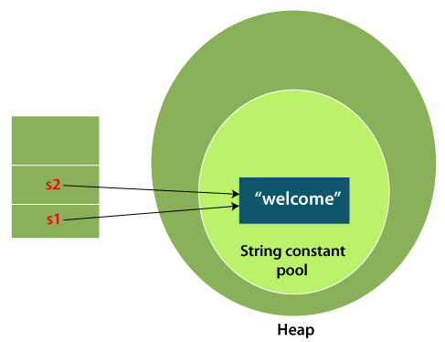

In the above example, only one object will be created. Firstly, JVM will not find any string object with the value "Welcome" in string constant pool that is why it will create a new object. After that it will find the string with the value "Welcome" in the pool, it will not create a new object but will return the reference to the same instance.

#### Note: String objects are stored in a special memory area known as the "string constant pool".

### Why Java uses the concept of String literal?

To make Java more memory efficient (because no new objects are created if it exists already in the string constant pool).

### 2) By new keyword

1. String s=**new** String("Welcome");//creates two objects and one reference variable

In such case, [JVM](https://www.javatpoint.com/jvm-java-virtual-machine) will create a new string object in normal (non-pool) heap memory, and the literal "Welcome" will be placed in the string constant pool. The variable s will refer to the object in a heap (non-pool).

### Java String Example

**StringExample.java**

1. **public** **class** StringExample{
2. **public** **static** **void** main(String args[]){
3. String s1="java";//creating string by Java string literal
4. **char** ch[]={'s','t','r','i','n','g','s'};
5. String s2=**new** String(ch);//converting char array to string
6. String s3=**new** String("example");//creating Java string by new keyword
7. System.out.println(s1);
8. System.out.println(s2);
9. System.out.println(s3);
10. }}

[**Test it Now**](https://www.javatpoint.com/opr/test.jsp?filename=StringExample)

**Output:**

java

strings

example

The above code, converts a **char** array into a **String** object. And displays the String objects **s1, s2**, and **s3** on console using **println()** method.

### Java String class methods

The java.lang.String class provides many useful methods to perform operations on sequence of char values.

|  |  |  |
| --- | --- | --- |
| **No.** | **Method** | **Description** |
| 1 | [char charAt(int index)](https://www.javatpoint.com/java-string-charat) | It returns char value for the particular index |
| 2 | [int length()](https://www.javatpoint.com/java-string-length) | It returns string length |
| 3 | [static String format(String format, Object... args)](https://www.javatpoint.com/java-string-format) | It returns a formatted string. |
| 4 | [static String format(Locale l, String format, Object... args)](https://www.javatpoint.com/java-string-format) | It returns formatted string with given locale. |
| 5 | [String substring(int beginIndex)](https://www.javatpoint.com/java-string-substring) | It returns substring for given begin index. |
| 6 | [String substring(int beginIndex, int endIndex)](https://www.javatpoint.com/java-string-substring) | It returns substring for given begin index and end index. |
| 7 | [boolean contains(CharSequence s)](https://www.javatpoint.com/java-string-contains) | It returns true or false after matching the sequence of char value. |
| 8 | [static String join(CharSequence delimiter, CharSequence... elements)](https://www.javatpoint.com/java-string-join) | It returns a joined string. |
| 9 | [static String join(CharSequence delimiter, Iterable<? extends CharSequence> elements)](https://www.javatpoint.com/java-string-join) | It returns a joined string. |
| 10 | [boolean equals(Object another)](https://www.javatpoint.com/java-string-equals) | It checks the equality of string with the given object. |
| 11 | [boolean isEmpty()](https://www.javatpoint.com/java-string-isempty) | It checks if string is empty. |
| 12 | [String concat(String str)](https://www.javatpoint.com/java-string-concat) | It concatenates the specified string. |
| 13 | [String replace(char old, char new)](https://www.javatpoint.com/java-string-replace) | It replaces all occurrences of the specified char value. |
| 14 | [String replace(CharSequence old, CharSequence new)](https://www.javatpoint.com/java-string-replace) | It replaces all occurrences of the specified CharSequence. |
| 15 | [static String equalsIgnoreCase(String another)](https://www.javatpoint.com/java-string-equalsignorecase) | It compares another string. It doesn't check case. |
| 16 | [String[] split(String regex)](https://www.javatpoint.com/java-string-split) | It returns a split string matching regex. |
| 17 | [String[] split(String regex, int limit)](https://www.javatpoint.com/java-string-split) | It returns a split string matching regex and limit. |
| 18 | [String intern()](https://www.javatpoint.com/java-string-intern) | It returns an interned string. |
| 19 | [int indexOf(int ch)](https://www.javatpoint.com/java-string-indexof) | It returns the specified char value index. |
| 20 | [int indexOf(int ch, int fromIndex)](https://www.javatpoint.com/java-string-indexof) | It returns the specified char value index starting with given index. |
| 21 | [int indexOf(String substring)](https://www.javatpoint.com/java-string-indexof) | It returns the specified substring index. |
| 22 | [int indexOf(String substring, int fromIndex)](https://www.javatpoint.com/java-string-indexof) | It returns the specified substring index starting with given index. |
| 23 | [String toLowerCase()](https://www.javatpoint.com/java-string-tolowercase) | It returns a string in lowercase. |
| 24 | [String toLowerCase(Locale l)](https://www.javatpoint.com/java-string-tolowercase) | It returns a string in lowercase using specified locale. |
| 25 | [String toUpperCase()](https://www.javatpoint.com/java-string-touppercase) | It returns a string in uppercase. |
| 26 | [String toUpperCase(Locale l)](https://www.javatpoint.com/java-string-touppercase) | It returns a string in uppercase using specified locale. |
| 27 | [String trim()](https://www.javatpoint.com/java-string-trim) | It removes beginning and ending spaces of this string. |
| 28 | [static String valueOf(int value)](https://www.javatpoint.com/java-string-valueof) | It converts given type into string. It is an overloaded method. |

# Immutable String in Java

A String is an unavoidable type of variable while writing any application program. String references are used to store various attributes like username, password, etc. In Java, **String objects are immutable**. Immutable simply means unmodifiable or unchangeable.

Once String object is created its data or state can't be changed but a new String object is created.

Let's try to understand the concept of immutability by the example given below:

**Testimmutablestring.java**

10 Sec

31.7M

702

Exception Handling in Java - Javatpoint

1. **class** Testimmutablestring{
2. **public** **static** **void** main(String args[]){
3. String s="Sachin";
4. s.concat(" Tendulkar");//concat() method appends the string at the end
5. System.out.println(s);//will print Sachin because strings are immutable objects
6. }
7. }

[**Test it Now**](https://www.javatpoint.com/opr/test.jsp?filename=Testimmutablestring)

**Output:**

Sachin

Now it can be understood by the diagram given below. Here Sachin is not changed but a new object is created with Sachin Tendulkar. That is why String is known as immutable.

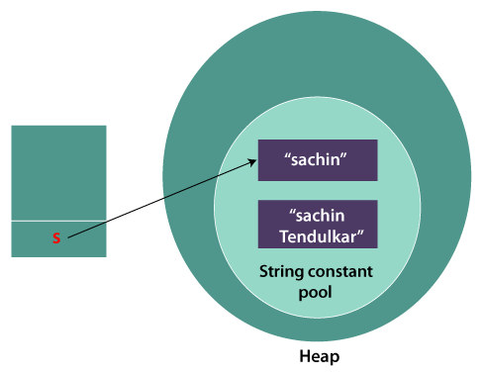

As you can see in the above figure that two objects are created but **s** reference variable still refers to "Sachin" not to "Sachin Tendulkar".

But if we explicitly assign it to the reference variable, it will refer to "Sachin Tendulkar" object.

For example:

**Testimmutablestring1.java**

1. **class** Testimmutablestring1{
2. **public** **static** **void** main(String args[]){
3. String s="Sachin";
4. s=s.concat(" Tendulkar");
5. System.out.println(s);
6. }
7. }

[**Test it Now**](https://www.javatpoint.com/opr/test.jsp?filename=Testimmutablestring1)

**Output:**

Sachin Tendulkar

In such a case, s points to the "Sachin Tendulkar". Please notice that still Sachin object is not modified.

### Why String objects are immutable in Java?

As Java uses the concept of String literal. Suppose there are 5 reference variables, all refer to one object "Sachin". If one reference variable changes the value of the object, it will be affected by all the reference variables. That is why String objects are immutable in Java.

# Java String compare

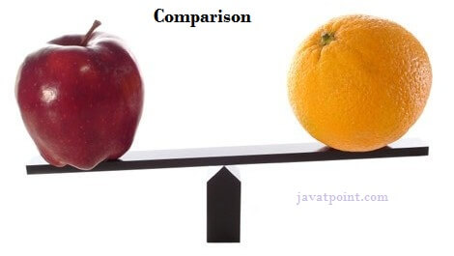

We can compare String in Java on the basis of content and reference.

It is used in **authentication** (by equals() method), **sorting** (by compareTo() method), **reference matching** (by == operator) etc.

There are three ways to compare String in Java:

1. By Using equals() Method
2. By Using == Operator
3. By compareTo() Method

## 1) By Using equals() Method

The String class equals() method compares the original content of the string. It compares values of string for equality. String class provides the following two methods:

Exception Handling in Java - Javatpoint

* **public boolean equals(Object another)** compares this string to the specified object.
* **public boolean equalsIgnoreCase(String another)** compares this string to another string, ignoring case.

**Teststringcomparison1.java**

1. **class** Teststringcomparison1{
2. **public** **static** **void** main(String args[]){
3. String s1="Sachin";
4. String s2="Sachin";
5. String s3=**new** String("Sachin");
6. String s4="Saurav";
7. System.out.println(s1.equals(s2));//true
8. System.out.println(s1.equals(s3));//true
9. System.out.println(s1.equals(s4));//false
10. }
11. }

[**Test it Now**](https://www.javatpoint.com/opr/test.jsp?filename=Teststringcomparison1)

**Output:**

true

true

false

In the above code, two strings are compared using **equals()** method of **String** class. And the result is printed as boolean values, **true** or **false**.

**Teststringcomparison2.java**

1. **class** Teststringcomparison2{
2. **public** **static** **void** main(String args[]){
3. String s1="Sachin";
4. String s2="SACHIN";
6. System.out.println(s1.equals(s2));//false
7. System.out.println(s1.equalsIgnoreCase(s2));//true
8. }
9. }

[**Test it Now**](https://www.javatpoint.com/opr/test.jsp?filename=Teststringcomparison2)

**Output:**

false

true

In the above program, the methods of **String** class are used. The **equals()** method returns true if String objects are matching and both strings are of same case. **equalsIgnoreCase()** returns true regardless of cases of strings.

[Click here for more about equals() method](https://www.javatpoint.com/java-string-equals)

## 2) By Using == operator

The == operator compares references not values.

**Teststringcomparison3.java**

1. **class** Teststringcomparison3{
2. **public** **static** **void** main(String args[]){
3. String s1="Sachin";
4. String s2="Sachin";
5. String s3=**new** String("Sachin");
6. System.out.println(s1==s2);//true (because both refer to same instance)
7. System.out.println(s1==s3);//false(because s3 refers to instance created in nonpool)
8. }
9. }

[**Test it Now**](https://www.javatpoint.com/opr/test.jsp?filename=Teststringcomparison3)

**Output:**

true

false

## 3) String compare by compareTo() method

The above code, demonstrates the use of **==** operator used for comparing two **String** objects.

## 3) By Using compareTo() method

The String class compareTo() method compares values lexicographically and returns an integer value that describes if first string is less than, equal to or greater than second string.

Suppose s1 and s2 are two String objects. If:

* **s1 == s2** : The method returns 0.
* **s1 > s2** : The method returns a positive value.
* **s1 < s2** : The method returns a negative value.

**Teststringcomparison4.java**

1. **class** Teststringcomparison4{
2. **public** **static** **void** main(String args[]){
3. String s1="Sachin";
4. String s2="Sachin";
5. String s3="Ratan";
6. System.out.println(s1.compareTo(s2));//0
7. System.out.println(s1.compareTo(s3));//1(because s1>s3)
8. System.out.println(s3.compareTo(s1));//-1(because s3 < s1 )
9. }
10. }

[**Test it Now**](https://www.javatpoint.com/opr/test.jsp?filename=Teststringcomparison4)

**Output:**

0

1

-1

# String Concatenation in Java

In Java, String concatenation forms a new String that is the combination of multiple strings. There are two ways to concatenate strings in Java:

1. By + (String concatenation) operator
2. By concat() method

## 1) String Concatenation by + (String concatenation) operator

Java String concatenation operator (+) is used to add strings. For Example:

**TestStringConcatenation1.java**

1. **class** TestStringConcatenation1{
2. **public** **static** **void** main(String args[]){
3. String s="Sachin"+" Tendulkar";
4. System.out.println(s);//Sachin Tendulkar
5. }
6. }

[**Test it Now**](https://www.javatpoint.com/opr/test.jsp?filename=TestStringConcatenation1)

**Output:**

How to find Nth Highest Salary in SQL

Sachin Tendulkar

The **Java compiler transforms** above code to this:

1. String s=(**new** StringBuilder()).append("Sachin").append(" Tendulkar).toString();

In Java, String concatenation is implemented through the StringBuilder (or StringBuffer) class and it's append method. String concatenation operator produces a new String by appending the second operand onto the end of the first operand. The String concatenation operator can concatenate not only String but primitive values also. For Example:

**TestStringConcatenation2.java**

1. **class** TestStringConcatenation2{
2. **public** **static** **void** main(String args[]){
3. String s=50+30+"Sachin"+40+40;
4. System.out.println(s);//80Sachin4040
5. }
6. }

[**Test it Now**](https://www.javatpoint.com/opr/test.jsp?filename=TestStringConcatenation2)

**Output:**

80Sachin4040

#### Note: After a string literal, all the + will be treated as string concatenation operator.

### 2) String Concatenation by concat() method

The String concat() method concatenates the specified string to the end of current string. Syntax:

1. **public** String concat(String another)

Let's see the example of String concat() method.

**TestStringConcatenation3.java**

1. **class** TestStringConcatenation3{
2. **public** **static** **void** main(String args[]){
3. String s1="Sachin ";
4. String s2="Tendulkar";
5. String s3=s1.concat(s2);
6. System.out.println(s3);//Sachin Tendulkar
7. }
8. }

# Substring in Java

A part of String is called **substring**. In other words, substring is a subset of another String. Java String class provides the built-in substring() method that extract a substring from the given string by using the index values passed as an argument. In case of substring() method startIndex is inclusive and endIndex is exclusive.

Suppose the string is "**computer**", then the substring will be com, compu, ter, etc.

#### Note: Index starts from 0.

You can get substring from the given String object by one of the two methods:

1. **public String substring(int startIndex):**  
   This method returns new String object containing the substring of the given string from specified startIndex (inclusive). The method throws an IndexOutOfBoundException when the startIndex is larger than the length of String or less than zero.
2. **public String substring(int startIndex, int endIndex):**  
   This method returns new String object containing the substring of the given string from specified startIndex to endIndex. The method throws an IndexOutOfBoundException when the startIndex is less than zero or startIndex is greater than endIndex or endIndex is greater than length of String.

In case of String:

10 Sec

Java Try Catch

* **startIndex:** inclusive
* **endIndex:** exclusive

Let's understand the startIndex and endIndex by the code given below.

1. String s="hello";
2. System.out.println(s.substring(0,2)); //returns he  as a substring

In the above substring, 0 points the first letter and 2 points the second letter i.e., e (because end index is exclusive).

### Example of Java substring() method

**TestSubstring.java**

1. **public** **class** TestSubstring{
2. **public** **static** **void** main(String args[]){
3. String s="SachinTendulkar";
4. System.out.println("Original String: " + s);
5. System.out.println("Substring starting from index 6: " +s.substring(6));//Tendulkar
6. System.out.println("Substring starting from index 0 to 6: "+s.substring(0,6)); //Sachin
7. }
8. }

**Output:**

Original String: SachinTendulkar

Substring starting from index 6: Tendulkar

Substring starting from index 0 to 6: Sachin

The above [Java programs](https://www.javatpoint.com/java-programs), demonstrates variants of the **substring()** method of **String** class. The startindex is inclusive and endindex is exclusive.

### Using String.split() method:

The split() method of String class can be used to extract a substring from a sentence. It accepts arguments in the form of a regular expression.

**TestSubstring2.java**

1. **import** java.util.*;
3. **public** **class** TestSubstring2
4. {
5. /* Driver Code */
6. **public** **static** **void** main(String args[])
7. {
8. String text= **new** String("Hello, My name is Sachin");
9. /* Splits the sentence by the delimeter passed as an argument */
10. String[] sentences = text.split("\\.");
11. System.out.println(Arrays.toString(sentences));
12. }
13. }

**Output:**

[Hello, My name is Sachin]

# Java String Class Methods

The **java.lang.String** class provides a lot of built-in methods that are used to manipulate **string in Java**. By the help of these methods, we can perform operations on String objects such as trimming, concatenating, converting, comparing, replacing strings etc.

Java String is a powerful concept because everything is treated as a String if you submit any form in window based, web based or mobile application.

Let's use some important methods of String class.

### Java String toUpperCase() and toLowerCase() method

The Java String toUpperCase() method converts this String into uppercase letter and String toLowerCase() method into lowercase letter.

31.4M

607

Difference between JDK, JRE, and JVM

**Stringoperation1.java**

1. **public** **class** Stringoperation1
2. {
3. **public** **static** **void** main(String ar[])
4. {
5. String s="Sachin";
6. System.out.println(s.toUpperCase());//SACHIN
7. System.out.println(s.toLowerCase());//sachin
8. System.out.println(s);//Sachin(no change in original)
9. }
10. }

[**Test it Now**](https://www.javatpoint.com/opr/test.jsp?filename=Testmethodofstringclass)

**Output:**

SACHIN

sachin

Sachin

### Java String trim() method

The String class trim() method eliminates white spaces before and after the String.

**Stringoperation2.java**

1. **public** **class** Stringoperation2
2. {
3. **public** **static** **void** main(String ar[])
4. {
5. String s="  Sachin  ";
6. System.out.println(s);//  Sachin
7. System.out.println(s.trim());//Sachin
8. }
9. }

[**Test it Now**](https://www.javatpoint.com/opr/test.jsp?filename=Testmethodofstringclass1)

**Output:**

Sachin

Sachin

### Java String startsWith() and endsWith() method

The method startsWith() checks whether the String starts with the letters passed as arguments and endsWith() method checks whether the String ends with the letters passed as arguments.

**Stringoperation3.java**

1. **public** **class** Stringoperation3
2. {
3. **public** **static** **void** main(String ar[])
4. {
5. String s="Sachin";
6. System.out.println(s.startsWith("Sa"));//true
7. System.out.println(s.endsWith("n"));//true
8. }
9. }

[**Test it Now**](https://www.javatpoint.com/opr/test.jsp?filename=Testmethodofstringclass2)

**Output:**

true

true

### Java String charAt() Method

The String class charAt() method returns a character at specified index.

**Stringoperation4.java**

1. **public** **class** Stringoperation4
2. {
3. **public** **static** **void** main(String ar[])
4. {
5. String s="Sachin";
6. System.out.println(s.charAt(0));//S
7. System.out.println(s.charAt(3));//h
8. }
9. }

[**Test it Now**](https://www.javatpoint.com/opr/test.jsp?filename=Testmethodofstringclass3)

**Output:**

S

h

### Java String length() Method

The String class length() method returns length of the specified String.

**Stringoperation5.java**

1. **public** **class** Stringoperation5
2. {
3. **public** **static** **void** main(String ar[])
4. {
5. String s="Sachin";
6. System.out.println(s.length());//6
7. }
8. }

[**Test it Now**](https://www.javatpoint.com/opr/test.jsp?filename=Testmethodofstringclass4)

**Output:**

6

### Java String intern() Method

A pool of strings, initially empty, is maintained privately by the class String.

When the intern method is invoked, if the pool already contains a String equal to this String object as determined by the equals(Object) method, then the String from the pool is returned. Otherwise, this String object is added to the pool and a reference to this String object is returned.

**Stringoperation6.java**

1. **public** **class** Stringoperation6
2. {
3. **public** **static** **void** main(String ar[])
4. {
5. String s=**new** String("Sachin");
6. String s2=s.intern();
7. System.out.println(s2);//Sachin
8. }
9. }

[**Test it Now**](https://www.javatpoint.com/opr/test.jsp?filename=Testmethodofstringclass5)

**Output:**

Sachin

### Java String valueOf() Method

The String class valueOf() method coverts given type such as int, long, float, double, boolean, char and char array into String.

**Stringoperation7.java**

1. **public** **class** Stringoperation7
2. {
3. **public** **static** **void** main(String ar[])
4. {
5. **int** a=10;
6. String s=String.valueOf(a);
7. System.out.println(s+10);
8. }
9. }

**Output:**

1010

### Java String replace() Method

The String class replace() method replaces all occurrence of first sequence of character with second sequence of character.

**Stringoperation8.java**

1. **public** **class** Stringoperation8
2. {
3. **public** **static** **void** main(String ar[])
4. {
5. String s1="Java is a programming language. Java is a platform. Java is an Island.";
6. String replaceString=s1.replace("Java","Kava");//replaces all occurrences of "Java" to "Kava"
7. System.out.println(replaceString);
8. }
9. }

# Java StringBuffer Class

Java StringBuffer class is used to create mutable (modifiable) String objects. The StringBuffer class in Java is the same as String class except it is mutable i.e. it can be changed.

Java StringBuilder class is used to create mutable (modifiable) String. The Java StringBuilder class is same as StringBuffer class except that it is non-synchronized. It is available since JDK 1.5.

How to create Immutable class?

There are many immutable classes like String, Boolean, Byte, Short, Integer, Long, Float, Double etc. In short, all the wrapper classes and String class is immutable. We can also create immutable class by creating final class that have final data members as the example given below:

Example to create Immutable class

In this example, we have created a final class named Employee. It have one final datamember, a parameterized constructor and getter method.

**ImmutableDemo.java**

1. **public** **final** **class** Employee
2. {
3. **final** String pancardNumber;
4. **public** Employee(String pancardNumber)
5. {
6. **this**.pancardNumber=pancardNumber;
7. }
8. **public** String getPancardNumber(){
9. **return** pancardNumber;
10. }
11. }
12. **public** **class** ImmutableDemo
13. {
14. **public** **static** **void** main(String ar[])
15. {
16. Employee e = **new** Employee("ABC123");
17. String s1 = e.getPancardNumber();
18. System.out.println("Pancard Number: " + s1);
19. }
20. }

**Output:**

Hello Java Program for Beginners

Pancard Number: ABC123

The above class is immutable because:

* The instance variable of the class is final i.e. we cannot change the value of it after creating an object.
* The class is final so we cannot create the subclass.
* There is no setter methods i.e. we have no option to change the value of the instance variable.

# Java toString() Method

If you want to represent any object as a string, **toString() method** comes into existence.

The toString() method returns the String representation of the object.

If you print any object, Java compiler internally invokes the toString() method on the object. So overriding the toString() method, returns the desired output, it can be the state of an object etc. depending on your implementation.

### Advantage of Java toString() method

By overriding the toString() method of the Object class, we can return values of the object, so we don't need to write much code.

Exception Handling in Java - Javatpoint

### Understanding problem without toString() method

Let's see the simple code that prints reference.

**Student.java**

1. **class** Student{
2. **int** rollno;
3. String name;
4. String city;
6. Student(**int** rollno, String name, String city){
7. **this**.rollno=rollno;
8. **this**.name=name;
9. **this**.city=city;
10. }
12. **public** **static** **void** main(String args[]){
13. Student s1=**new** Student(101,"Raj","lucknow");
14. Student s2=**new** Student(102,"Vijay","ghaziabad");
16. System.out.println(s1);//compiler writes here s1.toString()
17. System.out.println(s2);//compiler writes here s2.toString()
18. }
19. }

**Output:**

Student@1fee6fc

Student@1eed786

As you can see in the above example, printing s1 and s2 prints the hashcode values of the objects but I want to print the values of these objects. Since Java compiler internally calls toString() method, overriding this method will return the specified values. Let's understand it with the example given below:

## Example of Java toString() method

Let's see an example of toString() method.

**Student.java**

1. **class** Student{
2. **int** rollno;
3. String name;
4. String city;
6. Student(**int** rollno, String name, String city){
7. **this**.rollno=rollno;
8. **this**.name=name;
9. **this**.city=city;
10. }
12. **public** String toString(){//overriding the toString() method
13. **return** rollno+" "+name+" "+city;
14. }
15. **public** **static** **void** main(String args[]){
16. Student s1=**new** Student(101,"Raj","lucknow");
17. Student s2=**new** Student(102,"Vijay","ghaziabad");
19. System.out.println(s1);//compiler writes here s1.toString()
20. System.out.println(s2);//compiler writes here s2.toString()
21. }
22. }

**Output:**

101 Raj lucknow

102 Vijay ghaziabad

In the above program, Java compiler internally calls **toString()** method, overriding this method will return the specified values of **s1** and **s2** objects of Student class.

# Exception Handling in Java

The **Exception Handling in Java** is one of the powerful mechanism to handle the runtime errors so that the normal flow of the application can be maintained.

## What is Exception in Java?

**Dictionary Meaning:** Exception is an abnormal condition.

In Java, an exception is an event that disrupts the normal flow of the program. It is an object which is thrown at runtime.

## What is Exception Handling?

Exception Handling is a mechanism to handle runtime errors such as ClassNotFoundException, IOException, SQLException, RemoteException, etc.

### Advantage of Exception Handling

The core advantage of exception handling is **to maintain the normal flow of the application**. An exception normally disrupts the normal flow of the application; that is why we need to handle exceptions. Let's consider a scenario:

1. statement 1;
2. statement 2;
3. statement 3;
4. statement 4;
5. statement 5;//exception occurs
6. statement 6;
7. statement 7;
8. statement 8;
9. statement 9;
10. statement 10;

Suppose there are 10 statements in a Java program and an exception occurs at statement 5; the rest of the code will not be executed, i.e., statements 6 to 10 will not be executed. However, when we perform exception handling, the rest of the statements will be executed. That is why we use exception handling in [Java](https://www.javatpoint.com/java-tutorial).

## Hierarchy of Java Exception classes

The java.lang.Throwable class is the root class of Java Exception hierarchy inherited by two subclasses: Exception and Error. The hierarchy of Java Exception classes is given below:

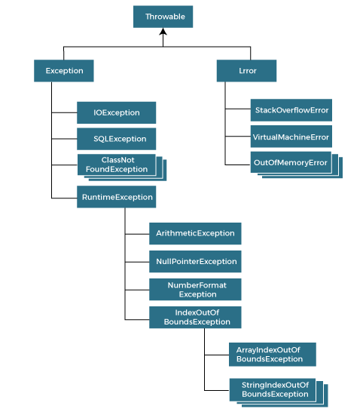

### Types of Java Exceptions

There are mainly two types of exceptions: checked and unchecked. An error is considered as the unchecked exception. However, according to Oracle, there are three types of exceptions namely:

1. Checked Exception
2. Unchecked Exception
3. Error

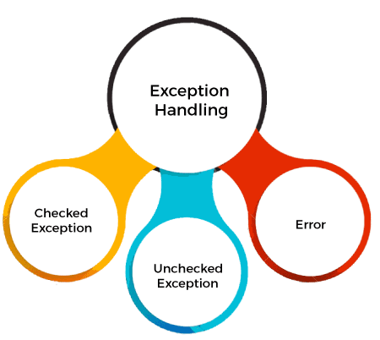

## Difference between Checked and Unchecked Exceptions

### 1) Checked Exception

The classes that directly inherit the Throwable class except RuntimeException and Error are known as checked exceptions. For example, IOException, SQLException, etc. Checked exceptions are checked at compile-time.

### 2) Unchecked Exception

The classes that inherit the RuntimeException are known as unchecked exceptions. For example, ArithmeticException, NullPointerException, ArrayIndexOutOfBoundsException, etc. Unchecked exceptions are not checked at compile-time, but they are checked at runtime.

### 3) Error

Error is irrecoverable. Some example of errors are OutOfMemoryError, VirtualMachineError, AssertionError etc.

## Java Exception Keywords

Java provides five keywords that are used to handle the exception. The following table describes each.

|  |  |
| --- | --- |
| **Keyword** | **Description** |
| try | The "try" keyword is used to specify a block where we should place an exception code. It means we can't use try block alone. The try block must be followed by either catch or finally. |
| catch | The "catch" block is used to handle the exception. It must be preceded by try block which means we can't use catch block alone. It can be followed by finally block later. |
| finally | The "finally" block is used to execute the necessary code of the program. It is executed whether an exception is handled or not. |
| throw | The "throw" keyword is used to throw an exception. |
| throws | The "throws" keyword is used to declare exceptions. It specifies that there may occur an exception in the method. It doesn't throw an exception. It is always used with method signature. |

## Java Exception Handling Example

Let's see an example of Java Exception Handling in which we are using a try-catch statement to handle the exception.

**JavaExceptionExample.java**

1. **public** **class** JavaExceptionExample{
2. **public** **static** **void** main(String args[]){
3. **try**{
4. //code that may raise exception
5. **int** data=100/0;
6. }**catch**(ArithmeticException e){System.out.println(e);}
7. //rest code of the program
8. System.out.println("rest of the code...");
9. }
10. }

[**Test it Now**](https://www.javatpoint.com/opr/test.jsp?filename=JavaExceptionExample)

**Output:**

Exception in thread main java.lang.ArithmeticException:/ by zero

rest of the code...

## Common Scenarios of Java Exceptions

There are given some scenarios where unchecked exceptions may occur. They are as follows:

### 1) A scenario where ArithmeticException occurs

If we divide any number by zero, there occurs an ArithmeticException.

1. **int** a=50/0;//ArithmeticException

### 2) A scenario where NullPointerException occurs

If we have a null value in any [variable](https://www.javatpoint.com/java-variables), performing any operation on the variable throws a NullPointerException.

1. String s=**null**;
2. System.out.println(s.length());//NullPointerException

### 3) A scenario where NumberFormatException occurs

If the formatting of any variable or number is mismatched, it may result into NumberFormatException. Suppose we have a [string](https://www.javatpoint.com/java-string) variable that has characters; converting this variable into digit will cause NumberFormatException.

1. String s="abc";
2. **int** i=Integer.parseInt(s);//NumberFormatException

### 4) A scenario where ArrayIndexOutOfBoundsException occurs

When an array exceeds to it's size, the ArrayIndexOutOfBoundsException occurs. there may be other reasons to occur ArrayIndexOutOfBoundsException. Consider the following statements.

1. **int** a[]=**new** **int**[5];
2. a[10]=50; //ArrayIndexOutOfBoundsException

## Java try block

Java **try** block is used to enclose the code that might throw an exception. It must be used within the method.

If an exception occurs at the particular statement in the try block, the rest of the block code will not execute. So, it is recommended not to keep the code in try block that will not throw an exception.

Java try block must be followed by either catch or finally block.

### Syntax of Java try-catch

1. **try**{
2. //code that may throw an exception
3. }**catch**(Exception_class_Name ref){}

### Syntax of try-finally block

1. **try**{
2. //code that may throw an exception
3. }**finally**{}

## Java catch block

Java catch block is used to handle the Exception by declaring the type of exception within the parameter. The declared exception must be the parent class exception ( i.e., Exception) or the generated exception type. However, the good approach is to declare the generated type of exception.

31.9M

551

Hello Java Program for Beginners

The catch block must be used after the try block only. You can use multiple catch block with a single try block.

## Internal Working of Java try-catch block

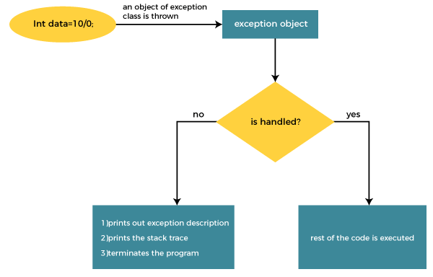

The JVM firstly checks whether the exception is handled or not. If exception is not handled, JVM provides a default exception handler that performs the following tasks:

* Prints out exception description.
* Prints the stack trace (Hierarchy of methods where the exception occurred).
* Causes the program to terminate.

But if the application programmer handles the exception, the normal flow of the application is maintained, i.e., rest of the code is executed.

## Problem without exception handling

Let's try to understand the problem if we don't use a try-catch block.

### Example 1

**TryCatchExample1.java**

1. **public** **class** TryCatchExample1 {
3. **public** **static** **void** main(String[] args) {
5. **int** data=50/0; //may throw exception
7. System.out.println("rest of the code");
9. }
11. }

[**Test it Now**](https://www.javatpoint.com/opr/test.jsp?filename=TryCatchExample1)

**Output:**

Exception in thread "main" java.lang.ArithmeticException: / by zero

As displayed in the above example, the **rest of the code** is not executed (in such case, the **rest of the code** statement is not printed).

There might be 100 lines of code after the exception. If the exception is not handled, all the code below the exception won't be executed.

## Solution by exception handling

Let's see the solution of the above problem by a java try-catch block.

### Example 2

**TryCatchExample2.java**

1. **public** **class** TryCatchExample2 {
3. **public** **static** **void** main(String[] args) {
4. **try**
5. {
6. **int** data=50/0; //may throw exception
7. }
8. //handling the exception
9. **catch**(ArithmeticException e)
10. {
11. System.out.println(e);
12. }
13. System.out.println("rest of the code");
14. }
16. }

[**Test it Now**](https://www.javatpoint.com/opr/test.jsp?filename=TryCatchExample2)

**Output:**

java.lang.ArithmeticException: / by zero

rest of the code

As displayed in the above example, the **rest of the code** is executed, i.e., the **rest of the code** statement is printed.

### Example 3

In this example, we also kept the code in a try block that will not throw an exception.

**TryCatchExample3.java**

1. **public** **class** TryCatchExample3 {
3. **public** **static** **void** main(String[] args) {
4. **try**
5. {
6. **int** data=50/0; //may throw exception
7. // if exception occurs, the remaining statement will not exceute
8. System.out.println("rest of the code");
9. }
10. // handling the exception
11. **catch**(ArithmeticException e)
12. {
13. System.out.println(e);
14. }
16. }
18. }

[**Test it Now**](https://www.javatpoint.com/opr/test.jsp?filename=TryCatchExample3)

**Output:**

java.lang.ArithmeticException: / by zero

Here, we can see that if an exception occurs in the try block, the rest of the block code will not execute.

### Example 4

Here, we handle the exception using the parent class exception.

**TryCatchExample4.java**

1. **public** **class** TryCatchExample4 {
3. **public** **static** **void** main(String[] args) {
4. **try**
5. {
6. **int** data=50/0; //may throw exception
7. }
8. // handling the exception by using Exception class
9. **catch**(Exception e)
10. {
11. System.out.println(e);
12. }
13. System.out.println("rest of the code");
14. }
16. }

[**Test it Now**](https://www.javatpoint.com/opr/test.jsp?filename=TryCatchExample4)

**Output:**

java.lang.ArithmeticException: / by zero

rest of the code

### Example 5

Let's see an example to print a custom message on exception.

**TryCatchExample5.java**

1. **public** **class** TryCatchExample5 {
3. **public** **static** **void** main(String[] args) {
4. **try**
5. {
6. **int** data=50/0; //may throw exception
7. }
8. // handling the exception
9. **catch**(Exception e)
10. {
11. // displaying the custom message
12. System.out.println("Can't divided by zero");
13. }
14. }
16. }

[**Test it Now**](https://www.javatpoint.com/opr/test.jsp?filename=TryCatchExample5)

**Output:**

Can't divided by zero

### Example 6

Let's see an example to resolve the exception in a catch block.

**TryCatchExample6.java**

1. **public** **class** TryCatchExample6 {
3. **public** **static** **void** main(String[] args) {
4. **int** i=50;
5. **int** j=0;
6. **int** data;
7. **try**
8. {
9. data=i/j; //may throw exception
10. }
11. // handling the exception
12. **catch**(Exception e)
13. {
14. // resolving the exception in catch block
15. System.out.println(i/(j+2));
16. }
17. }
18. }

[**Test it Now**](https://www.javatpoint.com/opr/test.jsp?filename=TryCatchExample6)

**Output:**

25

### Example 7

In this example, along with try block, we also enclose exception code in a catch block.

**TryCatchExample7.java**

1. **public** **class** TryCatchExample7 {
3. **public** **static** **void** main(String[] args) {
5. **try**
6. {
7. **int** data1=50/0; //may throw exception
9. }
10. // handling the exception
11. **catch**(Exception e)
12. {
13. // generating the exception in catch block
14. **int** data2=50/0; //may throw exception
16. }
17. System.out.println("rest of the code");
18. }
19. }

[**Test it Now**](https://www.javatpoint.com/opr/test.jsp?filename=TryCatchExample7)

**Output:**

Exception in thread "main" java.lang.ArithmeticException: / by zero

Here, we can see that the catch block didn't contain the exception code. So, enclose exception code within a try block and use catch block only to handle the exceptions.

### Example 8

In this example, we handle the generated exception (Arithmetic Exception) with a different type of exception class (ArrayIndexOutOfBoundsException).

**TryCatchExample8.java**

1. **public** **class** TryCatchExample8 {
3. **public** **static** **void** main(String[] args) {
4. **try**
5. {
6. **int** data=50/0; //may throw exception
8. }
9. // try to handle the ArithmeticException using ArrayIndexOutOfBoundsException
10. **catch**(ArrayIndexOutOfBoundsException e)
11. {
12. System.out.println(e);
13. }
14. System.out.println("rest of the code");
15. }
17. }

[**Test it Now**](https://www.javatpoint.com/opr/test.jsp?filename=TryCatchExample8)

**Output:**

Exception in thread "main" java.lang.ArithmeticException: / by zero

### Example 9

Let's see an example to handle another unchecked exception.

**TryCatchExample9.java**

1. **public** **class** TryCatchExample9 {
3. **public** **static** **void** main(String[] args) {
4. **try**
5. {
6. **int** arr[]= {1,3,5,7};
7. System.out.println(arr[10]); //may throw exception
8. }
9. // handling the array exception
10. **catch**(ArrayIndexOutOfBoundsException e)
11. {
12. System.out.println(e);
13. }
14. System.out.println("rest of the code");
15. }
17. }

[**Test it Now**](https://www.javatpoint.com/opr/test.jsp?filename=TryCatchExample9)

**Output:**

java.lang.ArrayIndexOutOfBoundsException: 10

rest of the code

### Example 10

Let's see an example to handle checked exception.

**TryCatchExample10.java**

1. **import** java.io.FileNotFoundException;
2. **import** java.io.PrintWriter;
4. **public** **class** TryCatchExample10 {
6. **public** **static** **void** main(String[] args) {

9. PrintWriter pw;
10. **try** {
11. pw = **new** PrintWriter("jtp.txt"); //may throw exception
12. pw.println("saved");
13. }
14. // providing the checked exception handler
15. **catch** (FileNotFoundException e) {
17. System.out.println(e);
18. }
19. System.out.println("File saved successfully");
20. }
21. }

[**Test it Now**](https://www.javatpoint.com/opr/test.jsp?filename=TryCatchExample10)